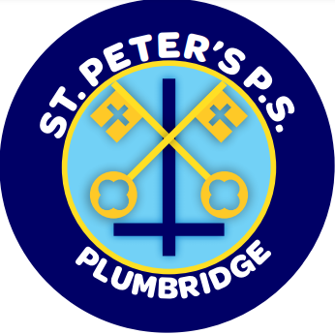
St Peter’s Primary School
415 Lisnaragh Road, Plumbridge, Omagh, BT79 8AF
Tel: 028 816 48412 info@stpeters.plumbridge.ni.sch.uk
Principal: Miss S Falls
14/10/21
Dear Parent/Guardian,

As part of Maths Week Ireland 2021 we have decided to hold a competition for all our pupils. This competition is to be completed at home and brought to school for Thursday 21st October. The focus for this year’s Maths Week is to develop the use of mathematical language, therefore we are asking pupils (with the help of adults) to take a photograph of somewhere in the outside world where they SEE maths in nature, e.g. patterns, sorting leaves, tallies, art etc Children are then to present this image as a word document/pic collage/format of their choice alongside a variety of mathematical questions they have composed to match their image. We expect 2 questions for pupils in P1/2, 3 questions for those in P3 and 5-10 questions for those in P.4-P7.
We hope you have fun with your child and enjoy hearing some of the maths activities they will take part in this week at school.
Kind regards,

S Falls

