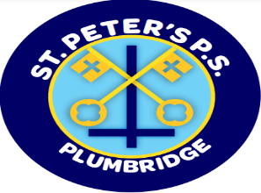
St Peter’s Primary School
415 Lisnaragh Road, Plumbridge, Omagh, BT79 8AF
Tel: 028 816 48412 info@stpeters.plumbridge.ni.sch.uk
Principal: Miss S Falls
14/9/21
Dear Parents/Guardians,
In light of the recent changes to the management of COVID – 19 in schools I wish to update you on the new procedures.

PHA will now complete contact tracing using a targeted approach. As stated today, in a letter to schools from DENI following advice from the chief Medical Officer dated 10th September.

The new, more focused approach to contact tracing in schools means that fewer, and in many cases no, close contacts will be identified in the case’s class. This is in line with the agreed approach being taken forward by the PHA based upon the prevailing public health position. This is a very different approach to that we have been taking until now and it is recognised that this may cause anxiety among the school community. The studies referenced in the CMO’s letter show that the previous approach resulted in many pupil close contacts self-isolating unnecessarily and is therefore no longer justifiable.

However, as a school we still require parents to let us know when your child tests positive and has to self -isolate so that we can make arrangements to send home work. This can be arranged by phoning the school at 9 a.m in the morning.
Advice is still the same if your child has symptoms of Covid 19, keep them at home and arrange a PCR test. You may find this phone number useful –
Contact Tracing Services – 028 9536 8888.

I hope this offers clarification on recent queries. I thank you for your support as we navigate our way through this current situation.

Keep safe
S. Falls
Principal

