St Peter’s Primary School
Plumbridge
415 Lisnaragh Road, Plumbridge, Omagh, BT79 8AF
Tel: 028 816 48412 info@stpeters.plumbridge.ni.sch.uk
Principal: Miss S Falls

23/08/20

Dear Parents /Carers,
I hope you and your families are all keeping safe and well and managing to enjoy the summer holidays.
We are delighted to welcome back all pupils on Wednesday 1st September. School begins at 9.15am with doors open from 9am. Primary 1 pupils can be accompanied to the class door during their settling in period. Children in P.1 will be collected at noon to Friday 1st October 2021. Pupils in year 2 and 3 will be collected at 2pm.
Pupils who travel by car should be dropped off at the top of the school path – children should not exit the car via the car door leading to the main road. In the interest of Health and Safety, Covid – 19 and Child protection, Parents are NOT Permitted to drive into the school grounds.
Staffing
Class arrangements for next year are;
Year 1 and 2 – Ms Gallagher Classroom Assistant – Mrs Hamilton
Year 3 – Miss Falls
Year 4/5 - Mr Mc Connell Classroom Assistant – Mrs Maguire, Miss Mc Bride
Year 6/7 – Mr Rouse Classroom Assistant – Miss Caldwell, Ms Mc Laughlin

Covid -19 Arrangements
As Covid -19 is sadly still present we will continue with many of our procedures from last year and will proceed with caution. Presently we are awaiting formal guidance from the Executive on the new self -isolation arrangements.
There will be a split break and lunch time.
Break Times Lunch Times
Year 1 – 3 - 10.30 – 10.45am 12am – 12.45pm
Year 4 -7 - 10.45 – 11am 12.30 – 1.15pm
No class will be eating in their classroom.
The Guidance is still the same if your child displays Covid-19 symptoms do not send your child to school.
Organise a PCR test and follow PHA guidelines. Keep the school informed and we take our direction from PHA.
If a child tests positive they are to stay at home and self - isolate.
Currently If the result is positive you should continue to self-isolate for 10 full days after the symptoms started.
You can end self-isolation 10 days after your symptoms started, as long as you do not still have a high temperature. If you still have a high temperature, you need to continue to self-isolate until your temperature has returned to normal for 48 hours.
The main symptoms of coronavirus (COVID-19) are a high temperature, a new, continuous cough and a loss or change to your sense of smell or taste.
Schools are still required to continue to support effective contact tracing.

- Children can now bring a school bag to school and it is important that all items are stored in the bag.

- Reading books can now be sent home.

- Lunch boxes should be reusable and easily cleaned each day.

- Children will be spaced as widely as possible with children seated facing the front of
the classroom.

- Children will stay within their class grouping as often as is possible.

- We will also be continuing with our hand washing regime on entry to school, at break, dinner and home time.

- School uniform will be worn. (except on P.E. days – days will be provided)

- All children will bring a pencil case to school – containing 2 pencils, a rubber, sharpener, coloured pencils/crayons/markers, and a glue stick.

- Pupils will go straight to their classrooms in the morning.

- Classes will enter via different entrances.

- Primary 1 and 2 Side door under the covering. – Door 4
- Primary 3 Main Door – Door 1
- Primary 4 and 5 Main Modular Door - Door 3
- Primary 6 and 7 Side Door of the School – Door 2

- No child on the school premises before 9 am.

- No other personnel other than staff, pupils and essential visitors will be permitted to enter the building unless by previous appointment.

- Parents are asked to wear masks when walking into the school grounds at noon (P1) and 2pm (P.2 / P.3).

- Parents are asked to maintain a 2m distance when waiting for their children (white markers on the wall and path indicate this)

- Parents are asked not to gather around the school gates.

- Hygiene will be crucial so it is important to discuss with your child the importance of correct hand washing, sneezing into a tissue – Catch it, Kill it, Bin it and maintaining social distance when possible.

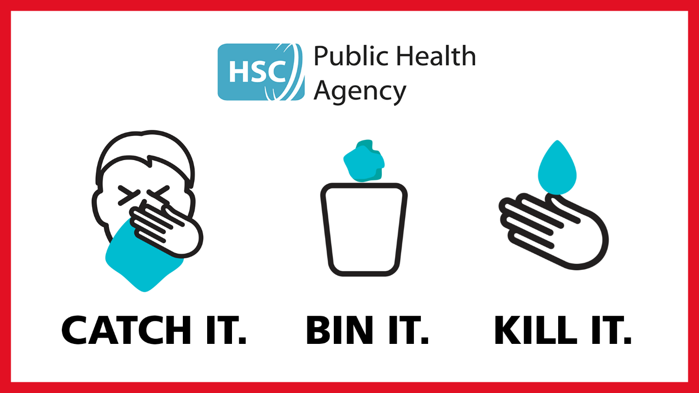

All children will be outside at break-time and dinner time so please ensure a waterproof coat and shoes are worn to school. It is so important that children maximise their opportunities to get fresh air.

Communication with Parents

Please ensure that you are signed up to the school website app so that you can get automatic alerts.

The school also has a texting service to parents – it is the responsibility of parents to inform the school if a mobile number has changed.

Also if you do not have mobile coverage it is important that you make contact with a parent in your child’s class who will pass this information onto you – this can be invaluable on school closure days.

It is of utmost importance that we have three contact names for children in school as contacts will have to be available to collect children if they are unwell. Please ring the school office between 9am and 12am to update contacts.

The Seesaw app. for schools will also be used this year. Your child’s teacher will send home new access codes and instructions on how to sign up at the beginning of September.

School Dinners/Milk
School dinners cost £2.60 /day. All monies must be sent into school in a marked envelope on a Monday stating child’s name and the day that they are taking dinner. All dinners need to be paid on a weekly basis.

Information on ordering school milk will be sent out next week.

School Dinners/Transport/Uniform
If you think that you may be entitled to help with the cost of School meals, uniform and have applied for bus transport please ensure that you have applied online or ring the Education Authority – (028) 90 418044 or email mealsanduniform@eani.org.uk
The next few weeks are crucial in helping to prevent the spread of Covid -19 and it is a team effort. We worked so hard last year and managed very well, let’s do the same this year.
I appreciate your continued support and understanding in these ever changing times but hopefully we will soon return to a more ‘normal’ school experience.
Yours Sincerely
S. Falls
S Falls
School Principal

