St Peter’s Primary School
Plumbridge
415 Lisnaragh Road, Plumbridge, Omagh, BT79 8AF
Tel: 028 816 48412 info@stpeters.plumbridge.ni.sch.uk
Principal: Miss S Falls Twitter A/c: @StPetersPlum1
14th May 2021
Dear Parents/Guardians,
I trust everyone is keeping well and enjoying the longer days.
Please find attached the latest Covid-19 advice from the Department of Education for Parents and for Pupils. Please read over and discuss with your child. It is important to follow the key advice. Again thank you for wearing your masks and remaining socially distanced at collection times. Sadly Covid 19 has not gone away yet!
Key Dates
First Confession Tuesday 18th May
(First Confession takes place in school – unfortunately due to current restrictions parents are still not permitted into the school. We trust that you understand.)
First Holy Communion Saturday 22nd May 2021 (11 a.m. in Sacred Heart Church)
Confirmation Thursday 3rd June 2021 (5 p.m. in Sacred Heart Church)
** Children making their Confirmation may leave school at 1 p.m. on this day
School Holiday From 26th May until 1st June inclusive
School Photographer
The school photographer will visit the school this Monday 17th May.
Sun Damage to Skin
As the warmer weather approaches and we are delighted to embrace brighter days it is important to remember that over exposure to the sun can lead to sun damaged skin. Therefore, we request that all children wear a sun hat and a high SPF sun cream (15+) applied generously on their skin before coming to school. Children can now wear sun dresses or navy shorts to school.
Yours sincerely

S Falls
Principal

Advice for Parents
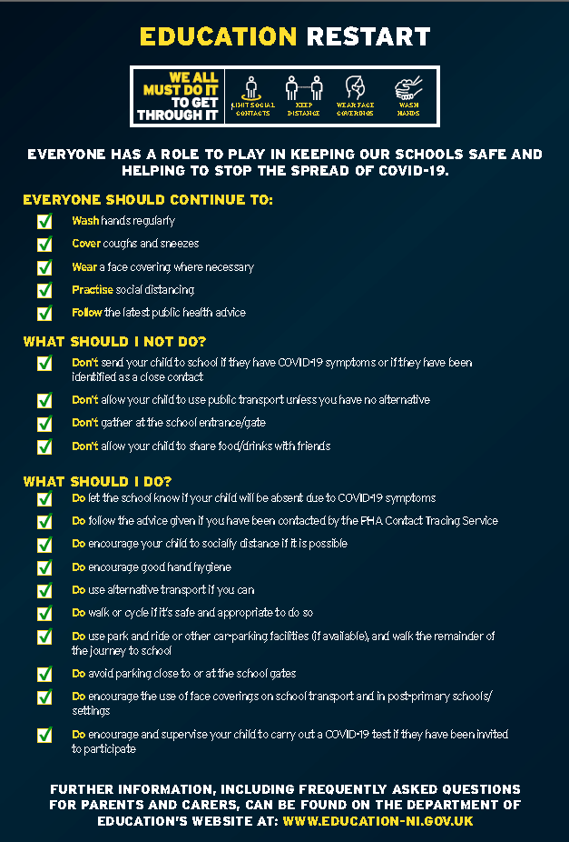

Advice for Pupils
