St Peter’s Primary School
Plumbridge
415 Lisnaragh Road, Plumbridge, Omagh, BT79 8AF
Tel: 028 816 48412 info@stpeters.plumbridge.ni.sch.uk
Principal: Miss S Falls Twitter A/c: @StPetersPlum1

16th October 2020
Dear Parents/Guardians,
The Executive has announced that schools and other educational setting will be closed to all pupils for two weeks.
The half term holiday has been extended from Monday 19th October until Friday 30th October. Schools will reopen on Monday 2nd November. As this is an extension of the Halloween break there will be no remote learning or work packs during this time. However, if your child wishes, they can source Abacus Maths and Accelerated Reading online.
It is unfortunate that it has come to this stage so quickly in the year but hopefully it will change the curve of Covid -19 for the best.
We all have a part to play and hopefully we will be mindful of ourselves, families and others in the community.
Presently in St Peter’s, everyone, (parents, children and staff) have been great in adhering to all Covid-related procedures.
May you all stay safe and have a lovely Halloween, following restriction guidelines of course!

(Glenelly Trust have may fun activities for your child over the Halloween period. See the poster on the school website).

Yours sincerely

S Falls
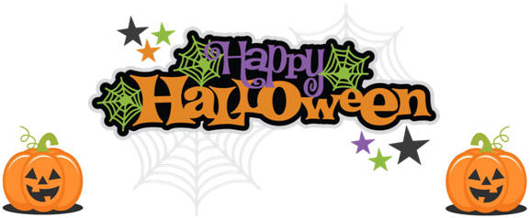
S Falls
Principal

