**St Peter’s Primary School**

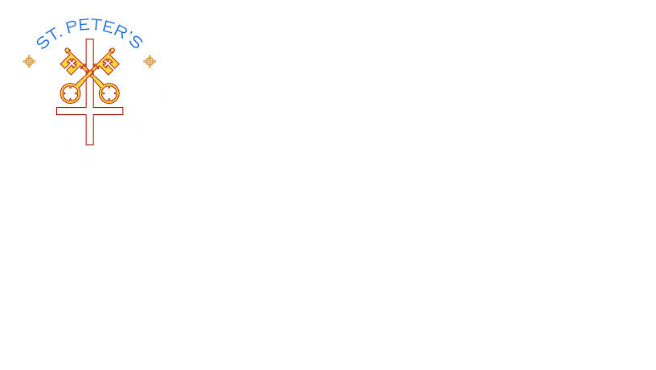

**Plumbridge**

**415 Lisnaragh Road, Plumbridge, Omagh, BT79 8AF**

**Tel: 028 816 48412** [**info@stpeters.plumbridge.ni.sch.uk**](mailto:info@stpeters.plumbridge.ni.sch.uk)

**Principal: Miss S Falls**

**27/08/20**

Dear Parents/Carers,

I trust everyone is safe and well and looking forward to coming back to school. The Year 7 pupils have been in all week and it is great to hear their voices and laughter in the building and playground. On Tuesday the 1st of September our school will be open to welcome all classes back after the longest summer holiday ever!

We are really looking forward to welcoming our twelve new Year 1 children – Caelin, Ellie, Dakota, Meabh, Michaela, Erin, Erin, Fearghal, Aoibhe, Lucy, Leon and Logan who will arrive after 9.30am. Parents can walk them down to the school for the first three days.

When your child returns to school new routines will be in place to help your child learn and follow COVID-19 protocols around the school. Our staff will strive to ensure your child feels comfortable returning to school and that they are aware of the new school routines in place.

Classes will have separate breaks and lunch times and hygiene procedures will be carefully followed. We do request that all children wear a **waterproof coat** as it is important for children to get fresh air throughout the day. Beforehand you could discuss with your child that most staff will be wearing head visors and some staff wearing face masks.

Included with this letter is a breakdown of Our Covid -19 Return to school practices and procedures in liaison with Staff and Board of Governors all of which has been based on the Restart guidance from DE (which is constantly changing as the situation unfolds) and the PHA Guidance.

As we journey into the unknown, there may be many changes and tweaks to our school day and as the minister of Education states; ‘this is not a return to business as usual’. If anyone has any questions, please do not hesitate to contact me at the school. We look forward to a safe return for all pupils and thank you for your patience and continued support.

Yours Sincerely,

S. Falls

S. Falls

Principal

***Heavenly Father, will you continue to walk with us and guide us through this difficult period. May we rest in your strength. Help us not to be fearful at what we see around us, but look to you knowing your Holy Spirit will lead and strengthen us’***

**Covid-19 Health and Safety Procedures for Parents**

**St Peter’s Primary School Plumbridge**

Covid-19 Health and Safety Checklist for Parents

|  |
| --- |
| **Entry / Exit and Circulation Considerations - Social Distancing** |
| * Drop off at the top school gates except where disability access is required. * Parents are requested not to congregate at the school gates and try to adhere to 2m social distancing. * Staggered drop off times:   Children in Yr. 5/6/7 with siblings in other classes – drop off 9.00 – 9.10am  Children in Yr. 4, 3, 2, and 1 drop off at 9.10 – 9.20am.  Bus children as usual.  Yr. 1 children are requested to come at 9.30am *if their parent wishes* to walk them to the class door on Tuesday the 1st – Thursday 3rd September, if not they can come on the bus or with a sibling at the normal time.  Yr 1 children collected at noon until 2nd October.  Yr 2/3 children collected at 2pm.  Yr 4 -7 children not using bus transport must be collected at 3pm.   * Children follow designated entry/exit points for each class on arrival and exit:   Ms Gallagher – Door 4 (side door of classroom)  Mr Rouse – Door 3 (new modular door)  Mrs Bradley – Door 2 (side door – the usual pupil entrance)  Miss Falls – Door 1 (main front Door)   * Each classroom will be allocated their own toilets.   Where possible, distancing will be observed between the teacher and children.  Where non-teaching staff support SEN or vulnerable pupils, consistently remaining with an individual pupil or a class, these adults should be viewed as part of the protective bubble and social distancing may be relaxed.   * Observe distance. Keep apart and line-up in single file to enter / exit classrooms.   Pupils in Yr 3 -7 will face forward in their class layout, at individual tables; this will not be practical with learning through play in the foundation stage (F.S.)     * Pupils in Foundation Stage will sit in zones with the same allocated group as far as possible throughout the day. * Outside appointments during the school day should be kept to a minimum. Pupils cannot return to school after appointments. * No parent to enter the school building unless a previous appointment has been agreed and PHA guidance followed. * It is the responsibility of the parent to check each child’s temperature before setting off for school and after returning from school. Any child with a high temperature should not set off for school.   *In order to ensure the success of the new procedures, we ask that parents are prompt in their arrival for their allocated time. If, for whatever reason, this is not possible, we would ask that parents contact the school office as soon as possible to notify the school of a late pick up.*  Other arrangements:   * No Assemblies initially. * P.E. coaches and games under review – awaiting guidance DE * Singing and Tin Whistle under review – awaiting guidance DE |
| **Limit shared resources TO AND FROM home** |
| * No School bag initially. * Pencil case to be left in school * Labelled snack, lunch box and water bottle required. * Paper copies will be limited. * Each child Yr. 3 – 7 have a pack of tissues which are to be left in school under their table. * Weekly dinner money to be sent in an envelope on Monday. |
| **Personal Hygiene** |
| * Children should be discouraged from touching their eyes, face, nose and mouth, putting hands/fingers into their mouths * Wash hands regularly throughout the school day * Sanitising stations clearly signposted in school. * Cough or sneeze into elbow or Tissue: Catch it Bin It Kill it * Follow mask protocol when wearing a face mask. * School uniform to be worn and washed regularly. Children should change out of their uniform when they return home. * On P.E. days children can wear their P.E. Kit to school – be aware of the weather and dress appropriately * Children must be able to tie their own laces in trainers/shoes. We encourage use of Velcro fasteners for children who can’t tie laces. * Regular cleaning of toilet facilities will occur throughout the school day. |
| **Classroom Hygiene** |
| * Surface cleaning will take place at intervals throughout the day. * The opening of doors and windows will be encouraged to increase natural ventilation and also to reduce contact with door handles. |
| **Catering** |
| * Year 1 children will leave at 12 noon but if your Year 1 child is entitled to free school dinners (and the school is in receipt of this information), you can collect a lunch at this time. Please let the school know in advance. * All cash will be sent in with your child each Monday in a sealed envelope. The name, class and number of dinners clearly labelled on the envelope. The correct amount of money will be in the envelope as no change will be given. Mrs Molloy will collect this on a Monday morning ONLY from each classroom. Dinner money each day is £2.60. * No milk will be provided in all schools. * The water fountain is **not available.** |
| **Personal Protective Equipment (PPE)** |
| * PPE equipment available to staff when required. |
| **Covid 19: Symptoms**  **Test, Trace and Protect Strategy** |
| * Do Not come to school if feeling unwell. * If a pupil presents with Covid19 symptoms, high temperature, persistent cough and anosmia he/she will be placed in an isolation area or outside if safe, until collected. Staff will wear PPE. Contacts must be ready to collect the child **IMMEDIATELY.** |
| **Communication** |
| * Follow all Covid-19 advice, regularly updated by PHA. * Contacts will be phoned to collect a child immediately if they present as unwell * In cases when a teacher is concerned about a child or if a child expresses concerns about feeling unwell then staff will check the child’s temperature. |
| **Transport** |
| Home to school transport should **only be used** where there **is no alternative available** (p.37 DE)   * It is mandatory for all pupils aged 13 and over to wear a face covering on public transport. It is also strongly recommended that all pupils, regardless of age, should wear a face covering on all buses, trains or taxis for the journey to school where it is appropriate for them to do so and they are able to handle them as directed. (Guidance from DE) |
| “Stay Safe, Be Responsible” |

***It is of vital importance that pupils are NOT sent to school if they or their family show any signs of Covid 19. A covid test is then carried out and the result forwarded to the school.***



Children and young people who exhibit any symptoms associated with COVID-19 should not attend educational settings. The Department of Health has implemented a contact tracing programme called *‘Test, Trace and Protect’* designed to control the spread of COVID-19.

All pupils are expected to follow the requirements of this programme: to self-isolate if they are identified as close contacts of cases and to obtain a test for COVID-19 if they develop symptoms. All members of their household should follow the appropriate isolation guidance as provided by the Public Health Agency.

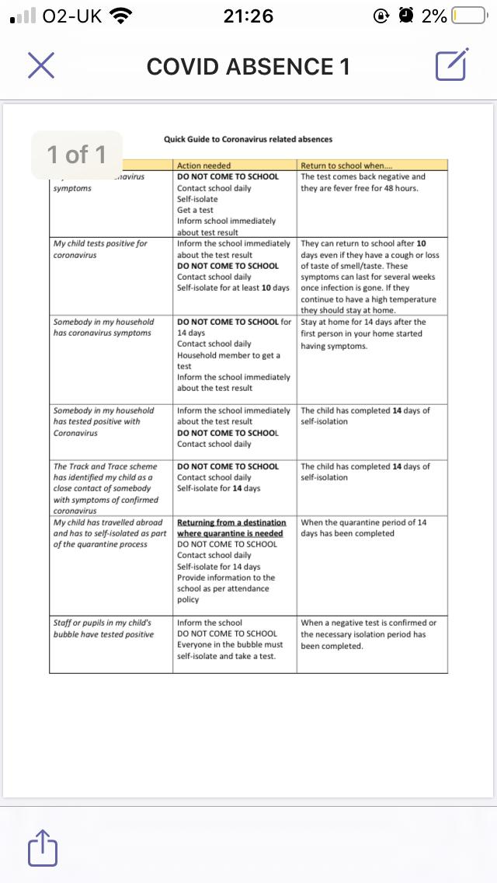

Prayer composed by our Year 7 pupil

Dear God,

We thank you for bringing us back safely to St Peter’s Primary School. We hope and pray that this will be a happy year for our whole school community. A year in which we feel your presence and protection in everything we do. Let our faith and trust in you be greater than ever.

Amen

