**St Peter’s Primary School**

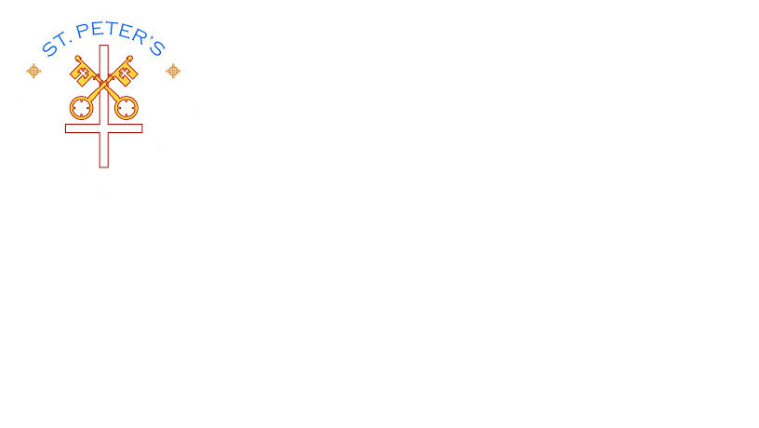

**Plumbridge**

**415 Lisnaragh Road, Plumbridge, Omagh, BT79 8AF**

**Tel: 028 816 48412 [info@stpeters.plumbridge.ni.sch.uk](mailto:info@stpeters.plumbridge.ni.sch.uk)**

**Principal: Miss S Falls**

22/8/20

Dear Parents/Carers of Yr. 7 children,

I hope everyone is keeping safe and well. We are looking forward to seeing the Yr. 7 children on Monday 24th August from 9.15 am to 2 pm except on Friday when children will finish at 12.30pm.

This week and the coming weeks will give the children opportunities to revise literacy and numeracy concepts, to participate in class discussions, to engage in creative lessons which encourage social interaction, as well as extended free time to enable socialisation with children in their class.

There are many new protocols and procedures in place, all designed to help protect the health and safety of everyone in the school community during COVID-19. Please see the attached page for details. These procedures will be reviewed/amended as new government guidance emerges. This is the ‘new norm’ and we need to be flexible in our approach and support each other during this unprecedented journey.

Meanwhile we look forward to hearing tales of lockdown while continuing to hope and pray that everyone will remain safe in our school community.

Yours Sincerely,

S.Falls

Principal

Pupil Attendance

Pupils who are clinically vulnerable or pupils who are in the clinically extremely vulnerable group or live with someone in this group have already been asked to contact the school and if in doubt specific advice should be sought from a Hospital Consultant or GP. before attending School. Advice in August from Dept of Education as follows;

**Pupils Who Live with Someone Who is Clinically Vulnerable**

If a child or young person lives with someone who is clinically vulnerable (but not clinically extremely vulnerable as above), including those who are pregnant, they can attend their education or childcare setting. If in doubt, advice should be sought from the Hospital Consultant or GP of the clinically vulnerable person.

**Pupils Who Were Shielding (clinically extremely vulnerable people)**

Advice with regard to shielding eased over time and as of 1 August 2020 ‘shielding’ has been paused. Pupil should follow the guidance of their hospital consultant or GP if in doubt about school attendance.

**Pupils Who Are Living with Someone Who Was Shielding**

Pupils who have household members who were considered clinically extremely vulnerable (at high risk of severe illness and requiring 'shielding'). These restrictions eased over time and from 1 August 2020 ‘shielding’ has been paused. Such children should have an individual risk assessment conducted before the most appropriate place of care is determined. (p.60/61 N.I reopening schools guidance)

***If in doubt, advice should be sought from the Hospital Consultant or GP of the clinically extremely vulnerable person.***

**Signs and symptoms of COVID 19.**

The main symptoms of Covid-19 are:

* **a high temperature** – this means you feel hot to touch on your chest or back
* **a new, continuous cough** – this means coughing a lot for more than an hour, or 3 or more coughing episodes in 24 hours (if you usually have a cough, it may be worse than usual)
* **a loss or change to your sense of smell or taste** – this means you've noticed you cannot smell or taste anything, or things smell or taste different to normal



Children and young people who exhibit any symptoms associated with COVID-19 should not attend educational settings. The Department of Health has implemented a contact tracing programme called *‘Test, Trace and Protect’* designed to control the spread of COVID-19.

All pupils are expected to follow the requirements of this programme: to self-isolate if they are identified as close contacts of cases and to obtain a test for COVID-19 if they develop symptoms. All members of their household should follow the appropriate isolation guidance as provided by the Public Health Agency

**Therefore, it is of vital importance that pupils are NOT sent to school if they or their family show any signs of Covid 19. A covid test is then carried out and the result forwarded to the school.**

**School Day**

Yr.7 take a healthy snack, lunch box, bottle of water, labelled pencil case (to be left in school - contents in previous letter) and a pack of tissues.

School uniform will be worn.

On arrival at school the children will walk down the school path – (if travelling by car exit the vehicle via the car door which opens onto the pavement.)

Children will walk down the path observing Social distancing.

Parents/Childminders who take children to school are asked are asked not to gather outside the school gates and to adhere to Social distancing.

No parent /childminder to drive into the school playground. (Unless exceptional circumstances discussed beforehand with myself)

Yr. 7 children will enter via the usual side door now called Door 2 – observing social distancing.

On arrival to the classroom they will wash their hands.

The children will be assigned a specific table and chair.

2m social distancing will be observed between the teacher and child.

Most Staff will be wearing head visors.

No more than one girl and one boy from each class may use the bathroom at the same time.

Children will eat their packed lunch in the classroom.

Staff will supervise break and dinner playtime.

There will be cleaning throughout the day of regularly touched surfaces and the toilets.

There will be no homework given this week.

At 2 pm parents will collect their child at Door 2 (side door) observing Social Distancing.

If a child displays symptoms of CovId -19 in school, named contacts will be phoned and it is important that the child will be collected **immediately.** The child will wait in a separate classroom – – i.e. classroom upstairs or if dry and suitable the child can wait outside with a staff member dressed in PPE.