St. Peter’s Primary School

Newsletter February 2024
Hoping everyone survived Storm Isha and Jocelyn. Let’s hope the weather improves!
Welcome
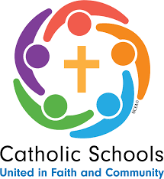
We welcome Erin Mulholland a fourth year Student from St. Mary’s University College, Belfast who will be completing her final year teaching placement in the Foundation Stage Classroom to Easter. We hope she has an enjoyable time with us. Erin will also take the Yr. 4- 7 children one hour a week for Irish.
During Catholic Schools Week
The theme for Catholic Schools Week this year was: Communities of Service.
Each of us belong to a community. This might be our local GAA club, our village or our town. Catholics belong to a special community of faith. We see this in our parish when people come together to pray to and worship God at Mass, to support each other in sad times and to celebrate important moments in life together. Jesus calls us to be a community and tells us that when we gather together in faith, hope and love, even in small numbers, he will be there too:

'For where two or three are gathered in my name, I am there among them'. (Mt 18:20)

This Catholic Schools Week, we celebrate and recognise the unique contribution our schools make at the service of our pupils, our communities and our Church. We hope you enjoyed the personal reflections and prayers on Seesaw and the school website each day. We hope Grandparents/ important person in your child’s life got their cards or portraits and prayer of thanks.
St Brigid’s Day
All classes will continue the tradition of making St. Brigid Crosses. The children will get to practise their skills and share their knowledge of making a ‘St. Brigid Cross’. Thank you to everyone who brought in rushes and shared their skills especially the grandparents. This is important for our Irish Culture to be maintained.

Confirmation
Confirmation is on Thursday 14th March in The Sacred Heart Church, Plumbridge at 6 p.m. There will be refreshments after in the hall. We ask that all children in Yr. 7 bring in £15 each towards the cost on Monday 5th February. There will also be a photographer present should you wish to avail of this service.

Post Primary Portal
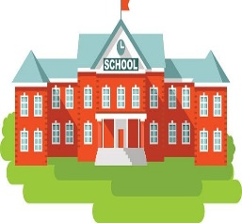
The Portal has now opened for Post Primary admissions. Information is posted on the website with a link to a video to help with this process. There is also an EA phone number if any parent needs support.
This Photo by Unknown Author is licensed under CC BY-SA

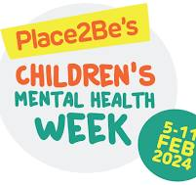
Mental Health Week
Children’s Mental Health Week takes place 5th – 11th February. This year the theme is ‘My Voice Matters’. It is important to provide children with time, space and opportunities to express themselves. Children who feel that their voices are heard usually have higher levels of self-efficacy, self-esteem, and a greater sense of community. Children want to be listened to and assured that their feelings are OK and may need guided through emotions that they find difficult. Listening and talking is essential and there are tips for families attached at the end of this Newsletter if you ever need to use them. Sometimes a hug is all that is required. Getting the balance right is essential.
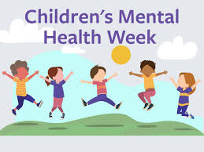
To celebrate this event the children will have a workshop from HiPsychology from their HIP ‘N HEALTHY series. Emotional Detectives Mental Health Week Megathon.
This aims to help children to experience, identify and manage emotions. This promotes the language needed to build their emotional development which will allow children to normalise negative emotions and give them the tools to navigate them.
This workshop will allow children to explore and engage in the world around them as well as form positive relationships.
P.6/7 will have their workshop on Monday 5th February and P.4/5 on 7th February. (More information attached.)Also, on Thursday 8th February all children can think of a short joke and share it with their class – ensure short and suitable!!

Free Break
The school has acquired support for providing a break for children. This will be on a Friday starting on 2nd February.
The children will receive a scone or pancake with butter, a fruit drink and a piece of fruit. This will ONLY be from February to Easter.

Toast for Trócaire
During Lent which starts on the 14th February the children in Yr. 4 – 7 are asked to bring in 20p for a slice of toast with butter. Also, the Student Council will visit each class, each day with the Trócaire Box and all children are encouraged to donate to this charity (every 5p can make a difference). It is important to encourage your child/ren to share and give to others.

Safer internet Day
Safer Internet Day 2024 will take place on the 6th of February 2024, with celebrations and learning based around the theme ‘Inspiring change? Making a difference, managing influence and navigating change online’.
Safer Internet Day is the UK’s biggest celebration of online safety. Each year we cover an online issue or theme that speaks to the things young people are seeing and experiencing online. Created in consultation with young people across the UK, this year Safer Internet Day will be focusing on change online, this includes covering:
- Young people’s perspective on new and emerging technology
- Using the internet to make change for the better
- The changes young people want to see online
- The things that can influence and change the way young people think, feel and act online and offline

Coordinated in the UK by the UK Safer Internet Centre, the celebration sees thousands of organisations get involved to promote the safe, responsible and positive use of digital technology for children and young people.

https://saferinternet.org.uk/safer-internet-day/safer-internet-day-2024/parents-and-carers

Follow this link for lots of help and advice to parents for digital devices and FAQs for their children.
Instructions are on page 11 of this Newsletter.

Again, we would kindly ask parents to consider downloading and using the Safer Schools NI App that we have previously sent out. Instructions are on page 11 of this Newsletter.
In this age of safeguarding and online platforms it is extremely important that parents keep abreast of new developments and we feel this app is very beneficial to parents and carers. It is FREE. The Department of Education have invested in this app and want all parents to be using this app.

This Photo by Unknown Author is licensed under CC BY-SA-NC
Relationships Sex Education
RSE is a compulsory part of the curriculum for children. The children in Yr. 7. will have the opportunity to attend a workshop in St Patrick’s P. S. Newtownstewart on 8th March from 9.15am – 12.15pm delivered by ‘Love for Life’ Parents have the freedom of choice if they wish their child to attend. (Parents were invited to the school last year to hear the content of the workshop). If you need to refresh your memory you can visit the website http://www.loveforlife.org.uk/our-programmes and the workshop is called ‘What’s Inside.’

It is important to have these conversations about puberty with your child at the appropriate time (usually P.7). Yr. 7 Parents, if you wish your child to participate in the programme, please return the permission slip which will be sent out shortly. Children attending need to be in school at 8.50am on the morning of 8th March as staff transporting the children will be leaving the school at 9am sharp. We are joining with Newtonstewart, in order to reduce the cost of this workshop.

Remember in relation to period dignity - there is a dresser in the girls’ toilets with free products should your child need to avail of them. Please feel free to tell your child that at any time they can approach Miss Falls or any member of staff if they need support or are feeling unwell.

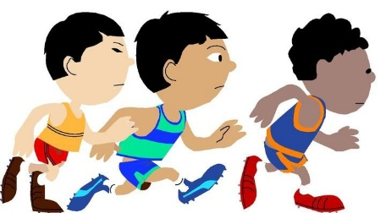
This Photo by Unknown Author is licensed under CC BY-SA-NC
Cross Country Running
On the 9th February Yr. 5 – 7 class will participate in St Mary’s Primary School Strabane annual Cross-Country Event at Holy Cross College, Strabane.
The event is for boys and girls, with a race for each year group from P.5 to P7.
The children can come to school dressed in their running gear (with the school uniform on top). The children will need to bring their uniform and a change of footwear to change back into as the weather could be inclement. Please wear warm clothes as it is an outdoor event.
Children should also bring a snack and a bottle of water. The children should be back at dinner time. Children who are spectating need to dress warmly as it can get cold standing on the track.

Eco Schools Update
The Eco Council have been busy. We have named our Sustrans Teddy Tracy! As part of our Eco work we are hoping to get a bronze certificate from Sustrans. Part of this involved the ‘Ditch the Stabilizers’ and ‘Pedal Ready’ Programme. Now we are taking part in the ‘Walking Bus’ Programme. This involves children who usually walk to school meeting at the G.A.A. Football Pitch each Wednesday in February at 9am sharp and walking to school. (Obviously it depends where you live in relation to the school). Waterproof coats needed and proper footwear. An adult will accompany them. A lady from Sustrans will be there Week 1 to join in the walk and talk to the children after about the benefits of walking and active travel.

Old batteries and used stamps can be sent into school for recycling. Please ensure that stamps have a centimetre or more of the envelope left around the rectangle, this is needed in order to recycle!

This Photo by Unknown Author is licensed under CC BY

Student Council

The Student Council have decided to have a ‘Book Swap’ on World Book Day. This is when each child is encouraged to take a book from home that they enjoyed into their class so that other children can read and take home. Please be aware that these books will not be returned. Staff will also participate in this exchange.

Credit Union Competition
This Photo by Unknown Author is licensed under CC BY
Congratulations to the boys and girls of St Peter’s who won the under 11 and under 13 section of the local slot in Plumbridge Hall.

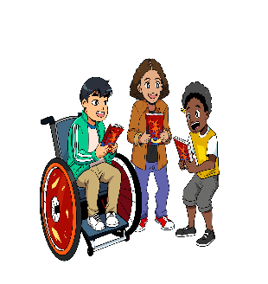
World book Day
World Book Day is on the 7thMarch. The children if they wish can dress up as a character from a book. We encourage you to think of home - grown ideas for costumes. The mission of world book day is simple;
To promote reading for pleasure, offering every child and young person the opportunity to have a book of their own.

Every child will have a £1 token home on Monday 5th February. Please do choose or swap your token at bookshops that are taking part. (Asda promotes £1 books – copies of titles on the back of the token but they sell out fast!)

Take the six elements of reading for pleasure and do a quick audit and see how well you are meeting these six key elements.
 | Being read to regularly | Having books | Having a choice in what you read | Finding time to read | Having trusted help to find a book | Making reading FUN!
At home

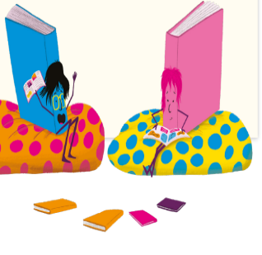
It is so important to include a bedtime story each night, good habits begin early and this helps foster a love for books.
In school each class will explore a book with science elements.

Holidays
The school will close for Mid - term –14th February to 16th February inclusive.

Thought for the Month

Walking Bus
Dear Parents,

We are hoping to set up a walking bus to help families choose a more active and sustainable journey to school. The key information is set out below. We would love you to join our first walking bus, which will be held on Wednesday 7th February.
What is a walking bus?
A walking bus is a group of children who walk together to school, supervised by adults.
Why are we setting one up?
- Health – walking to school incorporates more physical activity in children’s regular daily routine, which is also good for mental health.
- Environment – less driving means reduced greenhouse gases and air pollution, which is particularly important for children.
- Social – children (and adults) get to spend some time together on their way to school.
- Safety – reduces congestion round school and children learn how to safely walk to school.

How will it work?
We are running the walking bus during the month of February (7th,21st and 28th).
We will be meeting at the football pitch at 9am.
There will be staff there to supervise your children on the way to school. We will start to walk to school at 9am - if you arrive after this time, you will be responsible for walking your child to school.
Parents are welcome to stay with their children for the walking bus and can support with ratios for adult supervisors.
What happens after the February walking bus?
We would like to encourage you to walk or cycle to school with your children when possible. With the nicer weather coming into spring, it may be something you want to do weekly to improve your family’s fitness and to help reduce our schools carbon footprint.
We hope you can join us for our first walking bus, and this will become a popular choice for a healthy journey to school both for us and for the planet.

Best wishes,
The Eco Council

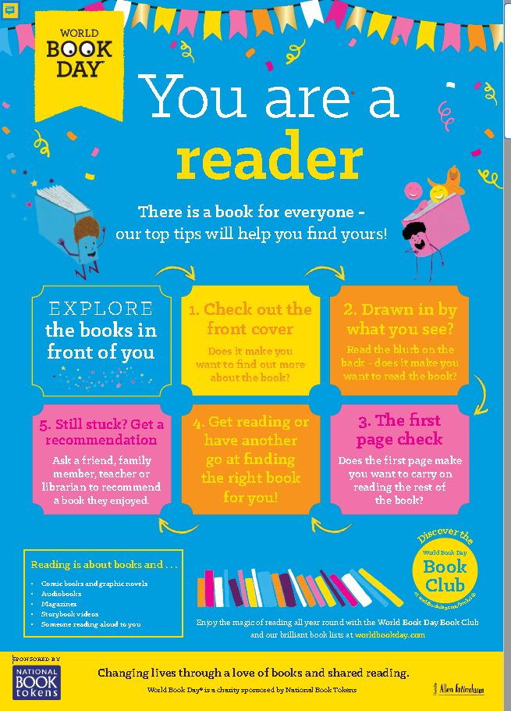

OUR P4-P7

MEGATHON EXTRAVAGANZA WILL FOCUS ON THE FOLLOWING CRUCIAL PILLARS:

ANGER
Children will identify what makes them angry. We explore how this emotion is both helpful and unhelpful.
We help them understand how to self-regulate when they experience unhelpful anxiety

JOY
Children will become aware of how they can 'find the joy' and 'spread the joy.' We also look at when joy turns into over excitement and how this can in fact be unhelpful. We further help pupils to self-regulate when experiencing over-excitement.

SADNESS
We take a delve into the emotion of sadness and how this is something that visits us all. We highlight the importance of speaking out when feeling 'big sadness.' There is further have fun in the classroom with 'music 'movement as two strategies to 'change a mood' when experiencing 'small sadness.'

PUPIL TOOL KIT
We will teach four evidence-based practical strategies that pupils can use to manage and overcome unhelpful anxiety.

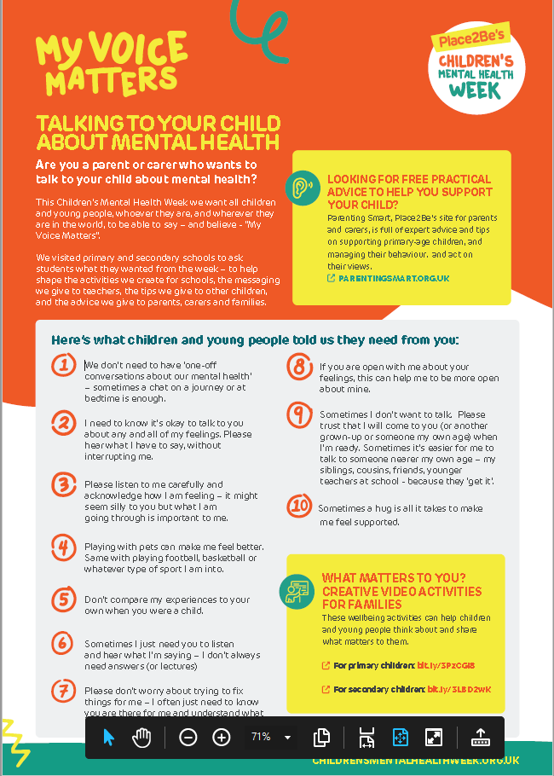

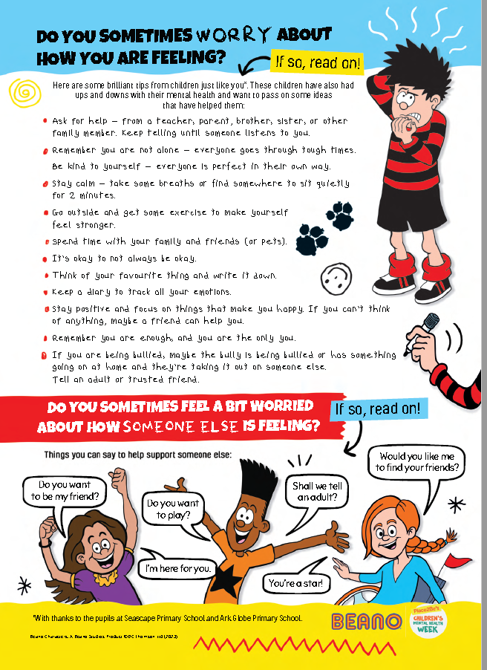

How to download the Safer Schools NI App

Are you a parent or carer using the Safer Schools NI App?
These steps will apply to all parents, carers, and staff members.
Firstly, as an adult user, you'll need to start by creating an account. We do not require the children to do this due to GDPR compliance. Your account is used to allow you to utilise the features within the App.
STEP 1 - Open the Safer Schools NI App. Select that you are a Parent/Carer.
Note If you are both a parent for a child in one school, and a member of staff in another, you're able to add both roles for both schools to your account. It doesn't matter if you choose staff or parent when you create your account.

STEP 2 - You'll now be prompted for an email address and password. If this is your first time, select 'Create an Account' in the box underneath the log in bar. Enter your name, use an email address you have access to and create a password. This could be your personal email address or a school one if you're a teacher.

STEP 3 - Once filled, click 'Register'. You'll then see a terms and conditions pop-up. Once this has been agreed to, your new account has been created and you'll be directed to the 'Add School Or Roles' page.
Note: These are the details you will use whenever you need to log in. Forgotten your password? Not a problem! Head to our article here to find out how to reset it.

STEP 4: Now you're logged in, we need to add your role or roles. This corresponds to your role within the school community. Once you've logged in for the first time, you'll be prompted to 'Add School'. These codes can be obtained from your school Admin Account holders. Each role has its own Entry Code and QR Code unique to each school.

Our Code is 7650!

Note All content is age and role appropriate, so as a parent you may see slightly different features or content, or have different capabilities than you do as a staff member.
Once you have the relevant one, enter the code or scan the QR code. You will then immediately be logged in to the corresponding role. These roles will be stored on your account until such a time as you need to remove them.
Note The Scan QR code option will open an in App camera to scan it with. This is the one that must be used otherwise it will not work.

How do I use my codes?
The 4 digit PIN number or the QR entry codes are provided by the school, and are unique to every school.
Note The Service Team at INEQE Safeguarding Group and Safer Schools will not be able to give out school entry codes for security reasons. If you're in need of a code, please contact your School.

