St. Peter’s Primary School

Newsletter June 2023

Football Tournament to honour the memory of our friend Matthew
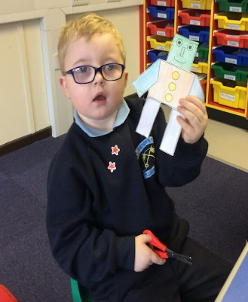
On Wednesday 7th June Glenelly GFC have organised a football Tournament in honour of our friend Matthew who sadly passed away in December 2020. Matthew was a member of Glenelly GFC and participated in the ‘Mini Blues’ youth coaching programme. Glenelly GFC along with Matthews parents and family have organised this tournament to honour his memory. The theme of the tournament is ‘Inclusivity’, i.e boys & girls of all abilities. Cranagh, Gortin, Greencastle and Dunamanagh schools will be attending this event and this is a fitting tribute to Matthew especially on the week of his heavenly birthday. Matthew was able to reach out to everyone and will always hold a special place in our hearts.

The Yr. 4 – 7 children will be involved in the tournament – with Yr. 4 and 5 children playing in the morning and Yr. 6 and 7 in the afternoon session.

This Photo by Unknown Author is licensed under CC BY-NC

School Trip

Key Stage 2 children will attend Brunswick Bowling Alley and the Cinema in Derry on Monday 5th June.

Key Stage 1 and Foundation Stage will visit the Gortin Glens and Duffland (Beragh) on Monday 12th June.

Children are not required to wear their school uniform on these trips.
Buses will be back approx. 2.30pm
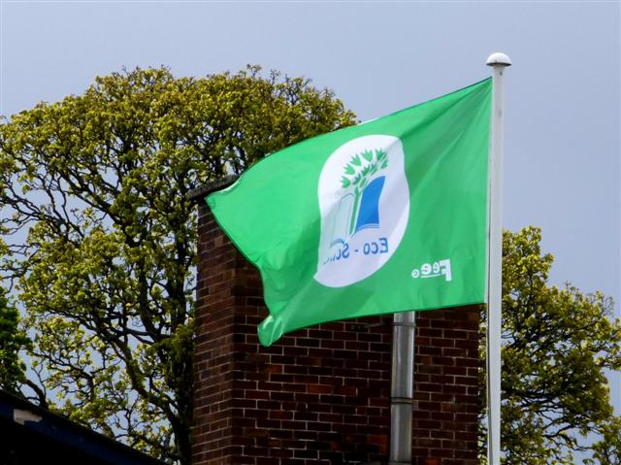

Wonderful News!

We have received news that our Green Flag application has been successful. This involved a tremendous amount of work and meeting with outside agencies; all with the view to promoting a healthier environment and understanding of the world we live in. Thanks must go to our Co – Ordinator Mrs Hegarty and The Eco Council who have been doing a superb job. This is supported by Annie Mullan who volunteers her time and has gained many grants for the school in this area. This is a wonderful achievement within two years. Well done everyone.
Author
On Wednesday 14th June an author Declan Carville will visit the school and provide the children with the opportunity to engage in activities that have been developed in partnership with AmmA.
Afterwards, the children can continue working on their creative story writing skills and continue to explore literacy through a bespoke resource pack.

Declan Carville is children's author from Northern Ireland with 12 published books to his name. Declan has been working in-partnership with EA AmmA Centre to offer a series of immersive storytelling and creative writing workshops for primary schools across Northern Ireland. During term 3, AmmA are funding Declan to visit 30 schools via our Creative Learning Partnerships fund.
During this workshop, Declan will work with a P.7 class on a range of themes that are discretely related to transition. ( We hope that he may take Yr. 6 children also)Transitioning from primary school to post-primary is a daunting time for many young people. 'Nelly Fandango' is picture story book, written by Declan and illustrated by Mel Carroll. Its themes relate to 'change', growing up, reflecting and looking forward. AmmA have developed a workshop with supporting materials that will allow Declan to look at these issues through the eyes of the characters in the book. The children will then immerse themselves in a character development journey where they can be expressive about the emotions, and the anxieties associated with change.
These workshops allow the children to go on a wonderful storytelling journey, following the characters on their adventures through a landscape that will feel familiar to the young people.
Football Tournament
On Friday 16th June (from 10am until approximately 2pm at the MUGA pitch at Gortin’s Owenkillew Community Centre) there is an inter-school KS2 football tournament organised by Gortin Primary School. A team of 8 players will be selected at random and parents will be asked to sign a permission slip.
There will be use of toilet facilities at the community centre throughout the day. Children should come dressed appropriately in school PE kit/football kit with shin guards and appropriate footwear, taking all weather into consideration (i.e. waterproof coats, sun cream, sun hats etc.) Children should bring a packed lunch and plenty of water.
Mental Maths Madness
Our Focus this year has been on Mental Maths strategies and to end the year we are having a Mental Maths Madness Morning on Friday 23rd June. Children can come to school dressed in clothes which have a number. We are delighted so far with the uptake of children playing Maths seeds and Mathletics. These will be available all over the summer and please make use of them as they may not be affordable within the school budget in the following year.
This Photo by Unknown Author is licensed under CC BY-SA-NC
Sports Day

Sports Day – Thank you to everyone who attended Sport’s Day this year. We hope you enjoyed it and well done to everyone for taking part. We also thank our local Vivo store for providing us with some resources for the day.
Induction for Yr. 1 Parents
All ‘new’ parents of children starting in Yr. 1 are welcome to attend an information session on Wednesday 21st June at 2.15pm. Children starting P.1 are welcome to visit the classroom on Thursday 22nd June from 9.30am – 10.30am.

Gardening Club

The After school Gardening club in June will be offered to the Yr. 4 children. The club finishes at 4pm sharp every Tuesday. We sincerely thank Annie Mullan who shares her expertise and love of the outdoors with the children.
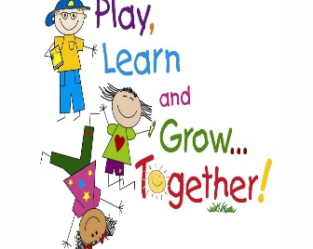
Student Council

Pupils have been enjoying the outdoor toys provided by the Fireside Quiz. These have been a great addition to our playground Fun!

Irish Lessons

Gaeilge ar scoil!
We have had a very successful Irish programme this year with MF Learning. We are very proud of all the P7s who are completing their Bronze Fáinne Irish speaking exams in association with the European Líofa programme which promotes fluency in Irish. Maith sibh! A special go raibh maith agaibh to Glenelly GAA club who funded Irish in the school for part of this year and to Michelle for her energetic fun filled lessons.. We hope to build on this success next year!

School Playground – Traffic Free

As the last month approaches, we thank everyone who has adhered to our traffic free approach in the playground. However, during this lovely weather, the children will be outside more often and we appeal to everyone to keep the playground traffic free – Unfortunately there is still a minority of parents/carers who continue to drive into the school yard. It is important that everyone plays their part to keep our children safe.

Cookery Demonstration from Livestock and Meat Commission

On Tuesday 23rd May the Livestock and Meat Commission provided a cookery demonstration of NIFQA beef to the Yr. 5/6/7 pupils. The children had an opportunity to sample the cooked dish – chili beef nachos. Wendy the facilitator also provided a talk to the pupils on the ‘farm to fork journey’ of local food and explained how our farmers produce beef and lamb to the world leading standards.

Post Primary Days
Our P.7. Pupils will attend the relevant days in their Post Primary School on Monday 12th June.

Post Primary Schools will contact the relevant children.

Leavers’ Assembly

On Wednesday 21st June at 10am the parents of the Yr. 7 class are warmly invited into school for End of Year Assembly. Year 7 children finish on Friday 23rd June.

Goodbye to our Yr. 7 children

Everyone at St Peter’s Primary wish Cara, Dara, Dáire and Jamie every success and happiness in their future. We have enjoyed your company and fun at St. Peter’s.

School’s out!
The school will close for a half day on Thursday 29th June at 11.30am. There will be no school dinner served that day.

School Reports
Every child will receive their school report in a sealed envelope on Monday 26th June.P.7 children will receive their reports Friday 23rd June. So, check school bags!

Thank you and Happy Holidays

Finally, on behalf of everyone at St Peter’s, I thank you for your support and co – operation throughout the year. Children will return to school on 1st September. I hope everyone has a fantastic summer and time to enjoy our great summer weather!

Thought for the Month.

‘While we try to teach our children all about life, our children teach us what life is all about’.
Angela Schwindt

