**St Peter’s Primary School**

**December Newsletter**

The final Newsletter of 2022, we are now in the season of Advent and looking forward to Christmas. During the Season of Advent, we are reminded of the need to stay awake, to be alert, to pray so that we are ready for the coming of Jesus into our lives. Pope Francis says, *“It is important to remain watchful, because one great mistake in life is to get absorbed in a* *thousand things and not to notice God.”*(Pope Francis)

Remembering Matthew

At this Christmas time keep Matthew and his Family in our thoughts and prayers. ***Matthew’s Beautiful Light Continues to Shine in Our Hearts.***

The Children from Yr. 3 -7 will attend Mass on Friday Morning. In memory of Matthew the school and the football club will host a Football Blitz in June with neighbouring schools - more details will follow nearer the time.

Christmas Plays



u

The Christmas Plays will take place in Plumbridge Hall on Monday 19th December at 7pm. Children are requested to be in the hall at 6.30pm.

Yr. 1 and 2 Play – ‘Everyone Loves a Baby’

Yr. 3 and 4 - ‘Tommy Turkey Runs Away’

Yr. 5, 6 and 7 – ‘Lights, Camels and Action’.

For the majority of, our children this is their first time performing on stage, so a massive well done to them, you their parents for supporting them and our amazing staff for all their hard work in preparing them.

Tickets will be limited to **4** per family due to seating capacity in the hall.

Tickets will go on sale on Wednesday 7th and Thursday 8th December in the school hall at 9.20am. Please send in a labelled envelope with the name of the child and money for tickets. These will be distributed by Friends of St Peter’s. Tickets cost £5.

Christmas Tickets

Thank you to the sponsors who generously donated prizes for the school tickets and raffle in the hall. It is greatly appreciated. Every family has now received a book of tickets to sell and we appreciate your support. This is our main fundraiser each year and it goes towards School buses, Accelerated Reading Scheme, Standardized Tests, Gaelic Coach, School Trip, to name a few. If anyone wishes to purchase more tickets, please ask any staff member.



DD01184_ Friends of St Peter’s

Friends of St Peter’s organised a very successful ‘Pillows and Popcorn’ afternoon. It was a sell - out. Thank you again to everyone and to those who supported.

Friends of St Peter’s also organised the Cash for Clobber collection.

A massive thank you to Friends of St Peter’s they have been invaluable in securing prizes for the Christmas draw and raffle. They have very generously given their time to sell tickets, meet and greet at the Christmas Play and help in organising and cleaning the hall. They are very pro - active and willing to support the school, this is necessary for the smooth running of our school and the successful delivery of events. Thank you very much and if anyone else wishes to give some time they are very welcome to join Friends of St Peter’s.

School Christmas Dinner

On Friday 9th December the School Christmas dinner will be served, to help get into the ‘Christmas spirit’ pupils may wear a Christmas jumper. Please do not buy anything new for this day. Please also be mindful it is a P.E. day.

Christmas Cards

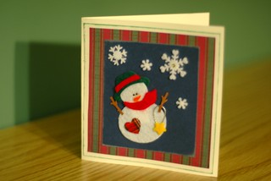

The children have made Christmas Cards for older members in our local community and the cards will be distributed by Glenelly Community Group. Hopefully every card will go some way to brighten someone’s day.  A lovely initiative, especially at this time of year.



Confirmation

Confirmation will take place for our Yr. 7 on Wednesday 15th March at 6.30p.m. in The Sacred Heart Church Plumbridge.

Communion

First Holy Communion will take place for our Yr. 4 Children on Saturday 22nd April at 11a.m. in the Sacred Heart Church in Plumbridge.



Resilient Rhythms

On 1st December all children will take part in Resilient rhythms. This programme is Music Therapy for children. The activities include purposeful breathing, action songs, expressive and creative use of voice and chants, body percussion and emotional regulation.

Anti – Bullying Week



All classes started Anti Bullying Week with an assembly on the theme ‘Reach Out’, children dressed in odd socks to raise awareness of bullying issues and to promote respect for everyone.

We ask Parents to reinforce this message at home. The key changes are in the use of language – for example we do not talk about a bully we refer to the child as displaying bullying behaviours.

As children spend a lot of time online it is important that parents have read the online posters that were put on the website. Sadly, there have been societal reports that cyber bullying has increased amongst children aged 11+years.

In class the children explored many scenarios and stories with an anti - bullying message. It is important as parents that you have supporting conversations with your child and reinforce key anti – bullying messages.

Road Safety

Road Safety Week was officially on 15th – 19th November. The school celebrated this with children completing activities in school and at home. The children will bring home a workbook of activities that they are working through so reinforce road safety message with the children. There is also information on the school website under the parent tab. Parent Guide to Road Safety for Children up to 7 years and 8 – 11 years. It is important to reinforce these key messages.

Farm Safety

Your child will also have a Farm Safety 2023 Calendar home and it is necessary that key safety measures are shared at home. Please discuss with your child.

Thank you

A fantastic total of 90 Shoe boxes were collected. This is a really worthwhile cause and it is so heartening to see our pupils and families and community thinking of others less fortunate than themselves, especially in the current climate!!! A huge thank you to everyone including members of the community who sent in shoeboxes. The boxes will be distributed in Romania.

Support Help lines

Many families may struggle over Christmas with the cost of living, there are agencies to help for example St Vincent de Paul, all calls are confidential.

Below are other phone numbers which you may find useful are there to support anyone;

24 Hour Domestic & Sexual Violence Helpline – 0808 8021414 or text support to 07797805839

The Hideout – [www.thehideout.org.uk](http://www.thehideout.org.uk) – space for young people to find out more about domestic violence.

 Football Blitz

The Yr. 5 – 7 children went to Omagh to a football Blitz, they mixed with children from Mountfield, Tattysallagh and Drumduff Primary School. This was facilitated by Tyrone County Board. The children also had a chance to experience Hurling.

Library Visit

The Yr. 2 children had an enjoyable visit to Strabane library. They listened attentively to all stories read and read books in the comfortable surroundings. The library is a wonderful resource and it is important to instil a love for books in the children. The library allows children to borrow up to nine books and keep for three weeks. When you have registered you can use any library.



Thankfully the school mobile Library will be returning to the school on a three - week cycle.

School Holidays



The School will close on Wednesday 21st December at 11 a.m.

The school will reopen on Wednesday 4th January.

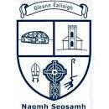 Congratulations To Glenelly Football Club

St Peter’s wish to congratulate St Joseph’s Gaelic Football Team on their recent anniversary. Football throughout the 90 years has survived in this parish and that is down to the community. It is our culture and something that we have great pride in as a parish and as a country. The children in this school have benefitted greatly from the club – the club has provided funds throughout the years to go towards payment of a Gaelic Tutor within the school and more recently Irish lessons beginning in January for the Yr. 3 -7 children. We wish the club continued success for the future and thank all past and present club volunteers for their dedication and commitment to Gaelic and Irish Culture.

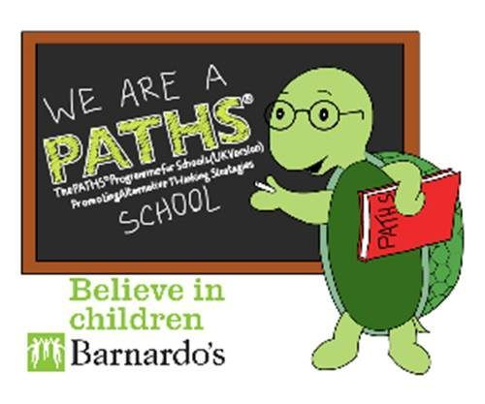**Paths Quote for December**

There is nothing wrong with wanting to be first,

**but not every time**!

There is nothing wrong with wanting to be the leader, either.

**But not every time**! It is important to take turns –

***it’s only fair!***

**Thought for the Month**

***Yesterday is history***



***tomorrow is a mystery.***

***Today is a gift - that’s why we call it ‘The Present’!!***

***On behalf of the Staff in the school I wish to take this opportunity to wish everyone a holy, happy, peaceful Christmas. I also wish to thank you for your support throughout the year.*** S. Falls

