St Peter’s Primary School
Newsletter
October 2022
A month completed and everyone has settled back into routine again. The P.1’s have settled in very well and are now staying to 2pm so there will be a lot of tired children and yawns this week at 2pm!

School communication
Text messages and the school website are our primary means of communicating. Please ensure that you have the app for the school website downloaded to your mobile phone as we are aiming to reduce the amount of paperwork used. If you change your contact details of phone number throughout the year, please inform the school office. Hopefully everyone has managed to connect to Seesaw if you need support, please contact the school.
Free school meals/uniform
Please have a look at the EA website https://www.eani.org.uk/financial-help/free-school-meals-uniform-grants to register your child for free school meals and uniform grant. If you are eligible for free meals and do not wish to avail of them, please register as the numbers of children eligible helps to raise our school budget. There is still time to apply. In a time when costs are rising, there is extra strain on the budget.
Attendance
It is important that children attend school regularly. This ensures progression and success in learning as well as building and maintaining strong friendships with peers. Parents must complete the online absence form which can be found on the school website – Parents – Absence). If absence falls below 90% or a pattern of absence emerges, the school will contact parents to find a way to improve attendance. The Educational Welfare Officer will also be involved. If your child is absent from school, please contact the school and provide a reason. At present the Covid isolation period is three days for children.
Parent – Teacher Meetings
Parent Teacher Meetings will take place on Monday 24th October and Tuesday 25th October. Each appointment is for 10 mins and staff will have to stay within this guidance so that all appointments are on time. Times will be shared later.
Maths Week
Maths Week will be celebrated from 15th to 23rd October. During this week the children will participating in many activities school trails and problem solving activities. There is a Parent Zone area to view if you wish, you will find this at www.mathsweek.ie At the end of this newsletter find attached some top tips for parents.

Teacher/Pupil Challenge
This is a fun event when the pupils and teachers challenge each other in fun events. On Tuesday 11th October the Teachers’ are looking forward to another win this year!
Halloween
The children can dress up for Halloween on Friday 28th October. There will be fun activities in each room and a Halloween Parade.
Eco Council /Student Council
Congratulations to all the boys and girls who took part in the Student/Eco Council manifestos. Everyone performed so well and came up with great ideas and it is a great occasion for the ‘pupil voice’ to be represented so well.
Pollination Grant
Thank you to Annie Mullan who successfully obtained a pollination grant for the school - £5,000. This is very welcome and needed to maintain our outdoor space.
Butterlope Farm
Thank you to Annie and Vinnie Mullan who provided the children in Key Stage 2 with a wonderful workshop and learning day on their farm on the theme ‘caring for the Sperrins.’
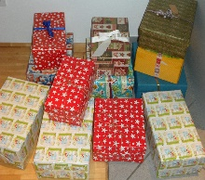
Shoebox appeal
This year we will continue with the Shoebox appeal. Each year the community of St Peter’s have donated gifts to those in need. Shoeboxes will be distributed to Albania, Bulgaria, Hungary, Romania and Ukraine. As many members of the community get involved in this project please spread the word!
By filling a shoebox with basic items, you can bring joy to those in need this Christmas. This is also a great way of encouraging your child to share with others in need. Leaflets have been sent home with your child today. Please do not send boxes into school as we have limited storage – we will let you know when the van will collect the boxes.
Friends of St Peter’s
The Friends of St Peter’s are meeting in Glenelly House in Plumbridge village on Monday 10th October at 7.00 p.m. New members are very welcome. The Friends of St Peter’s organise fund raising events for resources within the school. This year the school hopes to purchase Maths resources and Foundation Stage Play resources.
Please check Friends of St Peter’s via Facebook page.
Healthy Eating!!
In School we have a healthy eating policy which promotes healthy eating in school. Pupils are encouraged to only have milk or water and fruit at break-time and to have healthy lunch boxes.
Please see attached list for ideas at the end of the newsletter for suggested healthy options.
School Gates
Thank you to everyone for not driving into the school yard. The same applies to after school clubs.
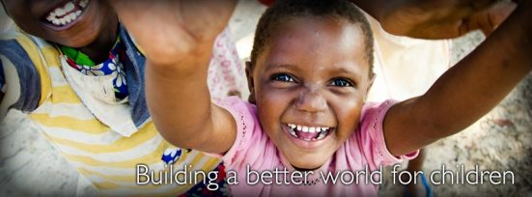
Children’s Mission Month
This Photo by Unknown Author is licensed under CC BY-NC-ND
On Tuesday 18th October we will have a non-uniform day when the children will donate £1 to Children’s Missions.
This October, we are celebrating World Mission Month, a month dedicated to the life-giving work of missionaries around the world.
This year, we walk hand-in-hand with the Church of Ethiopia and the local communities towards providing life-changing opportunities to those most in need. We are currently supporting a range of mission development programs in Ethiopia addressing malnutrition, the lack of access to education for young children, and the vulnerable position of women in society.
Pope Francis, in his 2022 World Mission Sunday message, invites everyone to answer the call to be missionary, sharing that "Mission is carried out together, not individually...".
For more information visit https://www.catholicmission.org.au/see-our-work-in-action
This helps children to develop an understanding that by being missionary and by living out the Gospel values they will become kinder and more socially and globally responsible.
Holidays
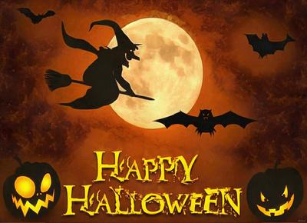
The school will close for Halloween Holidays from 31st October – 4th November. Happy Halloween!

World Smile Day
World Smile Day is celebrated Friday 7th October. Celebrate Kindness and the importance of a smile today.

Thought for the Month

A good life is when you smile often,
dream big, laugh a lot and realise
how blessed you are for what you have!!

Healthy Eating Options

Suggested food and drink options for healthy break/lunch choices

Apples | Flat bread
Oranges
Pineapple | Pancake
Bananas | Pitta pockets
Plums | Crackerbread
Pears | Salad
Watermelon | Peppers
Melon | Carrot sticks
Strawberries | Cheese
Blueberries | Humous
Raspberries | Dry cheerios
Grapes | Chicken
Cucumber | Ham
Tomatoes | Turkey
Peaches | Tuna
Mango | Yoghurt
Blackberries | Raisins
Cherries | Yoghurt raisins
Bread | Water
Brown bread | Milk
Bread rolls | Water
Wraps | Lunchables
 | Plain rice cakes
Breadsticks | Diluted Juice – sugar free (lunch time only)

TOP TIPS FOR PARENTS: From Maths Week Resources
This Photo by Unknown Author is licensed under CC BY
- Encourage children to think flexibly about numbers

- Encourage drawing whenever you can (mathematicians draw sketches all the time!)
3. When you help your children, do not lead them through step by step, as this takes away important learning opportunities for them.
4. Encourage children to work on problems that are challenging for them, so that they can learn from their mistakes
5. Encourage students to make sense of maths at all times (As they work, keep asking does that make sense to you? Why? or Why not? Discourage guessing)
6. Praise children by rewarding effort (not by telling them they’re smart)
7. Always have a positive outlook on maths
8. When children answer questions and get them wrong, try and find the logic in their answers
9. Give children maths puzzles
10. Play games! (For young children any board game with dice will help)

