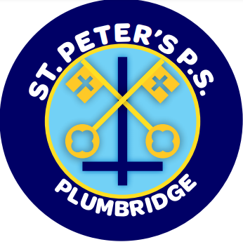
St. Peter’s Primary School

Newsletter June 2022

First Holy Communion

Many Congratulations to our wonderful P.4 Pupils – Aimee, Blathnáid, Cathal, James, Rose, Rosíe, Sarah who were like little angels on their First Holy Communion Day. The children all looked absolutely beautiful in their smart suits and stunning dresses and were a credit in how they participated in the Mass and received the sacrament. Thank you to Mr Mc Connell, Mrs Maguire, Ms Dillon, and the Yr.4 children in how well they prepared for this special occasion and we hope everyone had a lovely day. We would like to sincerely thank Fr. Donnelly, our school chaplain for his support and guidance. Also a huge thank you to Mrs Sweeney and the K.S. 2 children who came along to play and sing for the Yr.4’s on their special day, it really added so much to the occasion. Thank you also to the hall committee who provided welcome refreshments.

School Trip

The whole school Yr. 1 – 7 will visit Redcastle Leisureland on 21st June. Children are to wear their school uniform. The cost is £15 per child including food – (chips/burger; chips/sausages; a drink). The bus will return for all children at 2.45pm. Money is to be paid by Friday 17th June. So make carers aware of the later collection time in Yr. 1 and 2.

Post Primary Days

Our P.7. Pupils will attend the relevant days in their Post Primary School.
Wednesday 1st June – Holy Cross Strabane
Tuesday 31st May – Registration Christian Brothers Omagh
Thursday 9th June – Registration Loreto Omagh
Tuesday 14th June – St Colm’s Draperstown
Wednesday 22nd June – Drumragh College
Friday 24th June – Loreto Omagh

Post Primary Schools will contact the relevant children.

Leavers’ Assembly

Thursday 23rd June at 10am. All children can invite 2 people each to attend this End of Year Assembly.

Sports Day

Sports Day – (weather permitting) will take place on Friday 17th June. It will begin at 10am. If any parent wishes to attend they are welcome. However please remember you can only take photos of your own child.
Induction for Yr. 1 Parents
All parents of children starting in Yr. 1 are welcome to attend an information session on Monday 20th June at 2.15pm. Children starting P.1 are welcome to visit the classroom on Wednesday 22nd June from 9.30am – 10.30am.

After School Club

Sean nós Irish dancing is now finished for the term and the children did so well. There is lots of rhythm in Plumbridge.

Gardening Club

The Gardening club will continue on June 7th June and the 14th June. We sincerely thank Annie Mullan who shares her expertise and love of the outdoors with the children.
Cross – Country Event in Greencastle
The children enjoyed this event and whilst we had no winners it seems to have given some children a goal to work towards in the future – if not a new hobby.

Health and Well Being Workshop

The Yr. 6/7 children had a workshop on 19th May facilitated by Frank Diamond (ALPS). Frank was an inspirational talker and the children thoroughly enjoyed his workshop as did staff. The key theme was about gratitude and being thankful for the small things in life – Happiness is not about always getting what you want; it’s about enjoying what you have!

Cookery Demonstration from Livestock and Meat Commission

On Monday 6th June the Livestock and Meat Commission will provide a cookery demonstration of NIFQA beef to the Yr. 6/7 pupils. The children will have an opportunity to sample the cooked dish. The demonstrators will also educate the pupils on the farm to fork journey of local food and explain how our farmers produce beef and lamb to the world leading standards.

Goodbye and Thank you

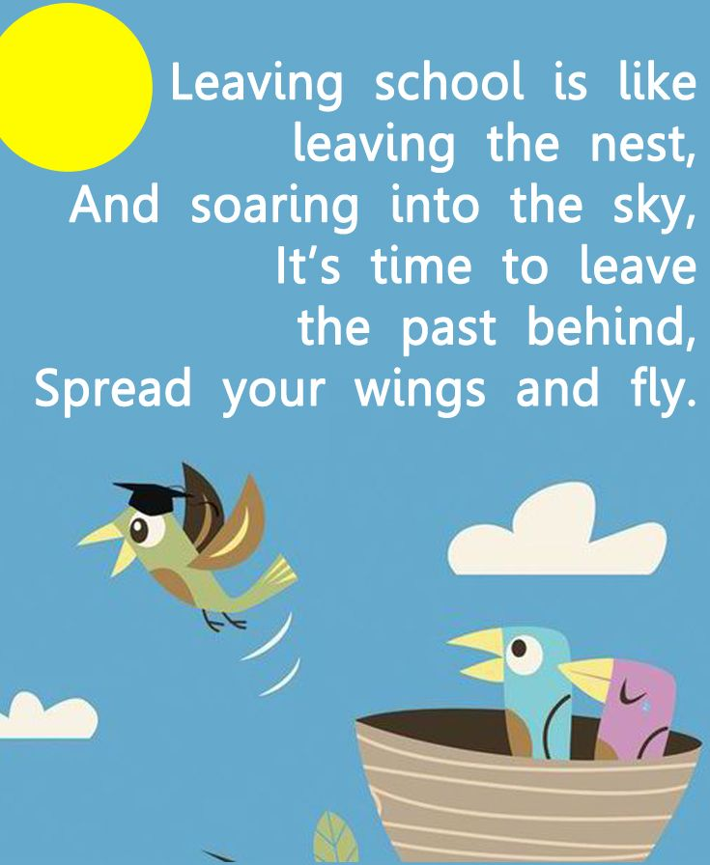
We offer a sincere thank you to Mr Mc Connell for all his hard work in P.4 and 5. We wish him all the best for the future.

Goodbye to our Yr. 7 children

All our Yr. 7 children will be visiting their post primary school and we wish all them the very best in their journey through life. We will certainly miss them and hope that they leave with treasured memories of St. Peter’s Primary School. Many children are going to various schools (6 feeder schools in total) and we hope that they will all keep in contact with each other as your primary school friends will always have a very special place in your heart.
Everyone at St Peter’s Primary wish Aaron, Aiden, Calvin, Caoimhín, Chloe, Clodagh, Dani, Darragh, Eimear, Emma, Johnnie, Mia, Orla, Patrick, Ronan, Saóirse and Tiernan success and happiness in their future. We have enjoyed your company and fun at St. Peter’s.

School’s out!
The school will close for a half day on Thursday 30th June at 11.30am. There will be no school dinner served that day.

Memo

School is closed on Monday 30th May to Friday 3rd June.

School Reports
Every child will receive their school report in a sealed envelope on Monday 27th June. So check school bags!

Thank you and Happy Holidays

Finally, on behalf of everyone at St Peter’s, I thank you for your support and co – operation throughout the year in what has been a few strange years. I hope everyone has a fantastic summer and time to enjoy our great summer weather!

Thought for the Month.
Shoot for the moon.
Even if you miss, you’ll land amongst the stars!!

