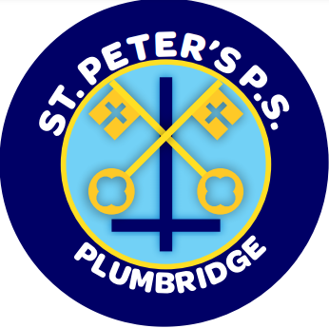
St. Peter’s Primary School

Newsletter April 2022

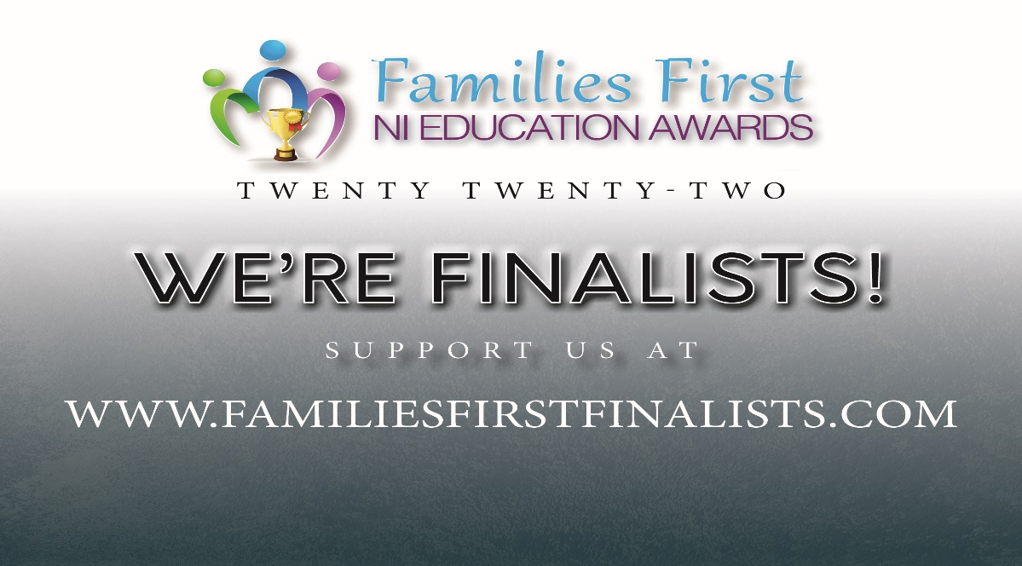
Families First NI Education Awards

We are so delighted to be nominated for a Families First Northern Ireland Award. We have been nominated by a Parent under the Category of Education Awards – Best School in Tyrone. The commenting lines close on Thursday 7th at noon.
Thank you to everyone who has already voted and left such wonderful comments.
Voting has now gone live and can be accessed under
www.familiesfirstfinalists.com/educationawards2022

When you reach this page, please scroll down to you see our school crest and click on the link.
You will be asked to provide your name, e-mail address and a reason why you think we should win.
The winner of the award will be decided based on the comments sent in by voters. It is not the number of votes but the quality of comments.

Please support our staff and whole school community by taking a few moments to comment and please send the above link to as many people as you can - past parents, past pupils, families, Governors, businesses, staff, visitors, etc can all vote.

Flooding in Foundation Room
The P.1/2 children are hopefully enjoying their new temporary accommodation. We are so fortunate to have a spare room in the building so that the children can continue to attend school. This room has only recently been painted with new carpet and lino so the children are very comfortable. I also want to particularly thank the staff who worked so hard clearing up and relocating rooms.
Confession

The Yr. 4 children will make their First Confession on Thursday 7th April at 7pm in the Sacred Heart Church. Children are to wear their school uniform.

First Holy Communion
First Holy Communion is on Saturday 7th May at 11am.
School Trip

The Yr5 -7 pupils will attend The Ulster American Folk Park, Omagh on Wednesday 27th April. The children in Yr. 6/7 have been studying the topic Farming and the Famine and this trip will help extend their learning. The children will need to bring a break, a bottle of water and a packed lunch. They will also need to wear their uniform and dress for the weather – waterproof coat/suncream!!!
Please complete and return the permission slip to your child’s class teacher by Friday 6th April.

Ukrainian Appeal

A Big Thank You to everyone at St. Peter’s P.S. for raising £550 during their walk and prayer for Ukraine. Continue to keep praying for peace.
Trócaire
Again the children have been donating very generously to Trócaire. Well done to our Student Council who have collected and counted money every day.

Easter competition

The local shop Vivo has sent in a colouring competition for the children. The prizes will be Easter eggs and every entry will get a crème egg or a malteaser egg. We also thank them for the ruler that each child received. The competitions can be returned to the school on Friday 8th April.

After School Club

Sean nós Irish dancing will return for P.6/7 classes on a Wednesday after school from 3 – 4pm. Your child will have home a permission slip, please complete. Classes will begin on Wednesday 27th April and finish on 26th May (5 weeks). Each session will cost £3. All monies to be paid (£15) for the 5 sessions on Monday 25th April.

Gardening Club

Gardening club will continue on a Tuesday for the Yr. 4/5 children beginning Tuesday 26th April from 3 – 4pm. The club will be facilitated by Mrs A. Mullan and Mr Mc Connell.

Cross – Country Event in Greencastle
Our Lady of Lourdes primary school are organising a Cross-Country Event for pupils of surrounding schools. It will take place on Wednesday 11th May 2022 at 10:00am at An Caisleán Glas GAA Club. I think this is a great opportunity for all children to take part /be aware of a cross country race.
Races: P5 Girls, P5 Boys, P6 Girls, P6 Boys, P7 Girls, P7 Boys.
Entry: Entries cost £2 per pupil and has to be paid by 11th April.
Prizes: There will be medals for pupils who place 1st, 2nd and 3rd in each category.
Outdoor play and sunscreen

It is wonderful to see the brighter sunny day and that means every child should come to school with sun - cream applied and wearing a sunhat during these warm days. Children from an early age should be made aware of sun safety. All children should also take a bottle of water with them to prevent dehydration.

Welcome back
It is great to see Ms Dillon return to school. We wish Miss Mc Bride all the best in the future and thank her for all the work in St Peter’s. We will miss her.

Monies

Violin money - £123.75.
Music Money for the Third Term - £6
Milk Money for the 3rd Term - £8.60
All monies paid on Monday 11th April

Holidays

Thursday 14th – Fri 22nd April (inclusive) – Easter break

Monday 2nd May – Bank Holiday

Thursday 5th May – School closed for the Election

Monday 30th May – Friday 3rd June – School Holiday

Happy Easter from everyone at St. Peter’s

