St. Peter’s Primary School

Newsletter February 2022
St Brigid’s Day

All classes made St Brigid’s crosses to celebrate St Brigid’s Day. Many teachers enjoyed learning new skills and it encapsulated our school motto ‘growing and Learning Together in God’s Love’. Thank you to all the children, parents and grandparents who provided us with rushes.

School Photographer

On Thursday the 10th February the school photographer will visit the school. Please ensure that your child is wearing the school uniform – (school sweatshirt not school hoodie for P.E.). Class and family photographs will be taken. If your child has no siblings at the school, then individual photos will be taken.

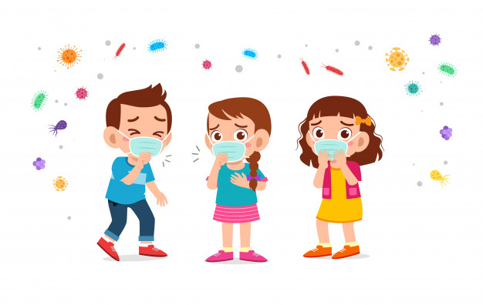
Covid -19 Guidelines Update

Covid – 19 is still in the community and we still have to be vigilant. On the website you will find a flow diagram posted (2/2/22) that may help you when you receive a positive result in your household. We ask that you continue to test your child on a regular basis and also if you could still wear masks when collecting your children. I do wish to say thank you as everyone has been great in playing their part. However, do be aware that if cases rise in a class we may have to resort to remote learning at short notice so do have a plan B in place ( we hope this will not be the case).

Guidance on isolation and close contacts can be found on www.nidirect.gov.uk

Memo if your child tests positive in a lateral flow please inform the school by phoning or out of hours message the class teacher via Seesaw.

If your child has symptoms and is showing negative on the Lateral flow tests, do book a PCR Test.

Post Primary Portal

The portal has now opened for admissions to post primary schools.
The children who wish to attend Loreto will receive a letter from the school stating that they are either the eldest in their family or that they have another sibling in the school. I have posted information on the website along with a short video in order to help with this process. If anyone needs support, please contact the school.

Culture Quarter

On Thursday 24th February the children in P4 -7 Will participate in a workshop ‘An introduction to Poland’.
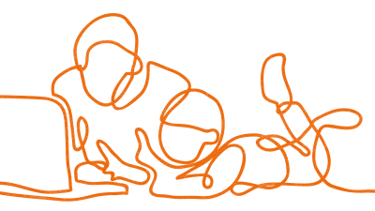
Safer Internet Day

Safer Internet Day will take place on 8th February with the theme ‘All Fun and Games,’ exploring respect and relationships online. During the pandemic statistics show that approx.77% of children have spent more time online playing games and using apps.

This is an area that needs to be closely monitored at home and parents should be aware of the age limits on games. Talk to your child about appropriate behaviour online and the importance of telling if someone’s behaviour online is making them feel scared or uncomfortable. Also when researching on the internet children should use the search engine ‘Kiddie’.
Please read over the smart rules below with your child. Also please make yourself familiar with the best practices for parents and carers as detailed below. On our school website under the parent tab there is more information on e-safety guidance.

The children will be participating in Internet Safety Awareness Activities during this week.

SMART Rules

Safe
Keep safe by being careful not to give out personal information when you’re chatting or posting online. Personal information includes your email address, phone number and password.

Meet
Meeting someone you have only been in touch with online can be dangerous. Only do so with your parents’ or carers’ permission and even then only when they can be present. Remember online friends are still strangers even if you have been talking to them for a long time.

Accepting
Accepting emails, messages, or opening files, images or texts from people you don’t know or trust can lead to problems — they may contain viruses or nasty messages!

Reliable
Someone online might lie about who they are and information on the internet may not be true. Always check information.

Tell
Tell a parent, carer or a trusted adult if someone, or something, makes you feel uncomfortable or worried, or if you or someone you know is being bullied online.

Best practices for parents and carers

Decide what’s right for your family
Creating a family agreement allows you to have conversations about setting boundaries. It’s important that you involve yourself in your child’s online world, so as a simple starting point you could ask them what their favourite websites or games are, and why they like them. The filtering options that you put in place may also change over time, as your children get older and more independent, and their technology use changes too.

Check your settings regularly
Children can become accomplished users of technology and may learn how to disable or bypass the parental controls in place. Therefore, it’s important to talk to your children from the outset about why the settings are there, and the importance of respecting them. Regularly checking the filtering on your family’s devices could also form part of your agreement.

Give children the skills they need
No parental controls or filtering options are guaranteed to be 100% effective. They are a very useful tool to improve the quality of online experiences, but they cannot offer a ‘complete’ solution. It is therefore essential to talk with your children about their online activities, so they know what to do if they encounter inappropriate content.

Establish some rules
If you have parental controls from your internet provider on your home WiFi, these will not cover the use of 3G, 4G or 5G at home. Similarly, if your child goes to a friend’s house where there are no controls in place, they may be able to access unrestricted content. For these reasons, it’s important to educate your child about the potential risks online and establish rules concerning the sites that are suitable or inappropriate to visit. Scan the QR Code to bring you to the safer internet website for more practical tips.
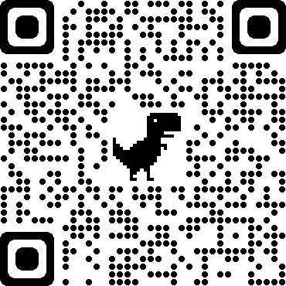

Click on the following web address https://youtu.be/shKnvCm0_lQ
to watch the video on Respect and Relationships Online in Gaming - Primary

Monies

Please pay all monies owing by Friday 11th February.
Milk - £13
Music - £8
Violin Tuition.

Funding

There is some funding available for families in financial hardship within the Strabane Area. This is a limited funding opportunity, and will be allocated on a first come, first served basis until the funding is exhausted. If anyone needs support or help please contact the school and speak directly to Miss Falls. Families cannot submit a self – referral, it has to be through the school principal. All information will be strictly confidential and there are times when everyone needs support and it is important that no family at St. Peter’s goes without help. The funding is there waiting to be assessed so don’t delay.

School Dinner

If anyone who is entitled to a free school dinner and they are off with Covid – 19 they can collect a school dinner from the canteen. Please let the cooks know in advance.

Congratulations
We extend warm congratulations to Mr. Rouse on the birth of his baby boy Joe.

A Warm Hello …..

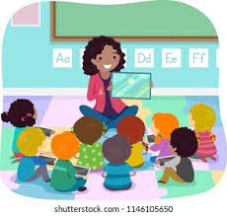
Currently in the school on a short term basis we have Miss E. Keatley in the Foundation Stage, Miss A. Devlin in Yr. 3 and Miss S. Varma in the upper classes.
We also extend a very warm welcome to Mr A. Harkin from St. Mary’s University College Belfast, who will join us next week and will be with us until Easter. Andrew already has had a few one-day visits. We hope he has a lovely time with us here and it is great to see a past pupil returning to the school.
Holidays

The school will close for Mid - term break on the 14th to 18th February.

Thought for the Week

Next week is mental Health Week and we will be continuing with our Neuronomic Programme. Let us all be kinder to each other and to ourselves during this week……

Life is like a book.
Some chapters are sad, some happy and some exciting.
But if you never turn the page,
you will never know what the next chapter holds.!

