Useful Apps
 | Name | Category | Cost | Information
 | Catch It | Mental Health | Free | Learn how to manage feelings like anxiety and depression with catch it. It will teach you how to look at problems in a different way, turn negative thoughts into positive ones and improve your mental wellbeing.
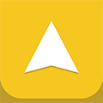 | Stress and Anxiety Companion | Mental Health | Free | Learn how to handle stress and anxiety on-the-go. Using breathing exercises, relaxing music and games designed to calm the mind, it helps you change negative thoughts to help you better cope with life's ups and down
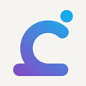 | Calm Harm | Mental Health | Free | Calm harm is designed to help people resist or manage the urge to self-harm. It's private and password protected.
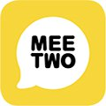 | Meetwo | Mental Health, Online Community, Child Health | Free | Meetwo provides a safe and secure forum for teenagers wanting to discuss any issue affecting their lives. You can anonymously get advice from experts or other teenagers going through similar experiences in areas such as mental health, self-harming, relationships and friendships.
 | Peanut | Pregnancy and Baby, Online Community | Free | Peanut aims to make sure no one must navigate womanhood alone, especially the hard parts. It gives you access to a social network to connect with other women across fertility and motherhood. It aims to make it easy to meet, chat and learn from like-minded women.
 | Pzizz | Sleep | Free | Pzizz helps you quickly calm your mind, fall asleep fast, stay asleep, and wake up refreshed. It uses "dreamscapes" – a mix of music, voiceovers and sound effects designed using the latest clinical research to help you sleep better at night or take power naps during the day.
 | Couch To 5K | Health and Lifestyle | Free | Walk and run your way to 5k this couch to 5k app designed to take total beginners from walking to running for 30 minutes in just 9 weeks. Presented in association with BBC get inspired, it builds you up gradually with a mix of running and walking.
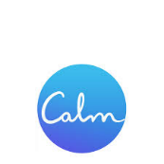 | Calm | Meditation and Relaxation Aid | Free | In the calm app, the daily calm is a 10-minute meditation that's new every day. Relaxing nature sounds from the calm app for relaxation, deep sleep and focus
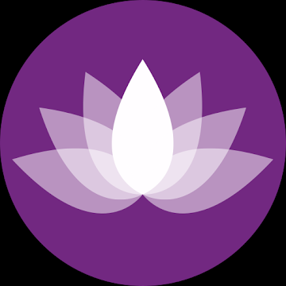 | My Affirmations | Live Positive | Free | Life does not happen to you; it happens for you. Your life is your creation. What you believe in will become your reality. Affirmations help you to change the outlook of your life by impregnating positive thoughts in your subconscious mind. Once you believe in a thought, that thought begins to manifest into reality.
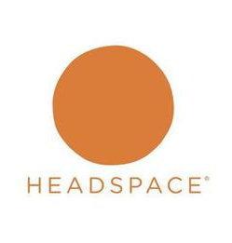 | Head Space | Sleep and Guided Meditation | Free | Meditation has been shown to help people stress less, focus more and even sleep better. Headspace is meditation made simple. We'll teach you the life-changing skills of meditation and mindfulness in just a few minutes a day.
 | 7 Cups – Anxiety & Stress Chat | Mental Health | Free | 7 cups connect you to caring listeners for free emotional support. Grow at your own pace. Explore self-help guides & growth paths for proven tips and advice on how to feel better.
 | Lets Meditate | Sleep and Guided Meditation | Free | A very straightforward approach to guided meditation; no clutter, no distraction. Just choose a track and hit play. It’s as simple as it can get.

