
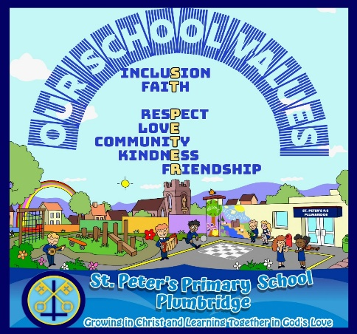
St. Peter’s Primary School
Plumbridge
Newsletter May 2026

Welcome to our May Newsletter! Somehow, we blinked, survived World Book Day costumes, and here we are already. The year is racing ahead — and we’ve still got plenty of work and fun (and a
little bit of organised chaos) to squeeze in!

School Values
You will notice that our school values now feature in our newsletter. These values are central to what makes St Peter’s a special place. This year, we have focused on embedding them across the school community, following consultation with all stakeholders. Parents have been invited to value‑focused assemblies, and children are reminded daily—both in class and during assemblies—of our core values. As we move through the year, it is timely to share and reaffirm the purpose and importance of these values with our families.

Values | Rationale
Inclusion | We are inclusive because God’s love is for everyone, and we celebrate each person as unique and important in our school community.
Faith | We are guided by faith as we grow in Christ, learn together, and show God’s love through our words and actions.
Respect | We respect each other’s feelings, beliefs, differences, and rights.
Love | We are rooted in love because it reflects God’s love for us and guides our actions towards kindness, forgiveness, and compassion.
Community | We are a community rooted in God’s love, where everyone is valued, supported, and encouraged to grow together.
Kindness | We are kind through caring words and actions, being fair and forgiving others.
Friendship | We are happy by developing friendships, sharing our talents celebrating our achievements and having fun

More information on our mission statement and vision can be found at the back of this newsletter. Also attached in this letter is a copy of the rationale for our school crest which has been shared with children.

Uniform Survey

Schools have been asked by DE to consult with parents on our school uniform – this will be sent out in the coming weeks.

May Altar

Children are encouraged to bring in flowers for the May Altar and say the rosary as a family. Information on praying the Rosary with your child can be found on the website under Our School and selecting Religion and then scrolling to praying the rosary. Responsibility for the May Altar is allocated each week to a class. (Flowers can be bluebells, apple blossoms etc.)
May 13th is the Feast of Our Lady of Fatima. Our Lady of Fatima’s message
emphasises peace, patience, purity, and perseverance. She also encouraged the
daily saying of the Rosary for Peace.

First Holy Communion and Choir
Congratulations to all the children who made their First Holy Communion and to all the children who gave their time and sang and played music in the choir. It was certainly evidenced in our school value of Community. It was a beautiful occasion and we are extremely proud of our 16 children in yr 4 who made their First Holy Communion. We thank Mrs Bradley for all her work and preparation.
Fan the Flames Mass
All children who have received the sacrament of Confirmation in the diocese this year are invited to Celtic Park GAA Grounds at 11am on Thursday 4th June. Mass will be celebrated by Bishop McKeown, the children wear their uniform and take a snack and lunch. The children will be transported by staff from the school.

Thank you
This Photo by Unknown Author is licensed under CC BY

Thank you to the Credit Union who donated £250 to the School Funds. Congratulations to Eireann, Daithi, Brenna, Grace and Eva who won the Easter Colouring competition and received an Easter Egg. Remember any child can save with the credit Union – money is collected every Wednesday in the school and a little each week can add up.

Transform Ed

Currently there are plans for curriculum reform in NI. TransformED NI will outline a comprehensive strategy for the transformation of teaching and learning in Northern Ireland. The strategy focuses on the core areas of curriculum, assessment, qualifications, school improvement and tackling educational disadvantage. Schools are to take two extra days to train on many of the changes. We are taking Friday 22nd May and have already taken Monday 16th March. Next Year we are to take 3 days.

Applause - Charity Monies
A tremendous thank you to the children, parents and staff who donated very generously to charity during Lent. Also, to the student Council who kept a daily and weekly tally of the money collected. The total raised has been amazing - £465!
Trócaire - £300
Mary’s Meals - £165


Tyrone Cumann na mBunscol

On Wednesday 6th May the Yr 6/7 children and the Yr 5 boys will attend Gortin to take part in a blitz. The yr 5 boys are going in order to field a boys team.

Chrildren are to wear football boots (trainers if they do not own boots), a gum shield, a snack and drink.

Children are asked to wear navy shorts and if they own a Matthew jersey to please take one. (we would appreciate if some families have a few jerseys in their home, please take into school on Tuesday for other children).


School Apps

The school has invested in Apps to help all children to consolidate their learning. The use of Mathsletics, Reading Eggs and Mathseeds are encouraged and not just for set homework. We also encourage Accelerated Reading and Reading for Enjoyment.


Helping Hands Programme

The children in Yr. 4 will complete the ‘Helping Hands Programme’ this term facilitated by Mr. Rouse who is trained in this Programme. It is a preventative education programme, developed by Women’s Aid NI for primary school aged children at key stages one and two. The overall aim of the programme is to: Increase children’s understanding of feeling safe and to explore and promote behaviours which will contribute to a safe environment. Mrs Bradley will take Yr 6/7 for ‘Beyond Bricks Programme’.

School Sports Day
A provisional date for School Sports day is Friday 12th June at 10am. We ask that all children wear P.E. Kit and sunscreen to school.

School Trip

The children in Yr 1 – 7 will visit Arena 7 in Letterkenny on Monday 15th June. The children in Yr 1-3 will play in the soft play area, the children in Yr 4 -7 will play laser tag and bowling.

The cost / child in Yr 1 – 3 will be £15 and the children in Yr 4 -7 will pay £20 each. Food is included in both costs and the school will subsidize the cost of the bus.

Please inform adults collecting Yr. 1/2 children that the children will be back at 3pm.

The school will fund the cost of buses on these trips. Both Trips will have food included. Children need to take a drink/break with them.
Monies to be paid by 29th May.


Parental Involvement in Numeracy

Super proud of our Yr. 3 parents and children who participated in the P.I.N Programme. Well done. We hope you enjoyed this experience with your child and that the games helped build confidence within the subject.

Accelerated Reading

Congratulations to Shea, Erin, Aoibhean, Erin and Eireann who have made it onto the ‘Word Millionaire’ Wall. Let’s hope we have some more before June!

Teeth Cleaning

The Children in Year 1 – 2 have received a free toothbrush and toothpaste as part of a project to reduce dental decay in The West. Please ensure that your child brushes their teeth every morning and night.


Gardening School Club
Gardening club will continue on Wednesday 6th May – this time for the Yr 6 children . Thank you again to Annie Mullan who freely shares her time and expertise with the school. Potato Seedlings were planted and we are hoping for a bumper crop.

Cycling Proficiency
Every Wednesday the Yr. 7 will take part in the Cycling Proficiency Programme with Mrs Mossey from 2 -3pm.

Transfer Support
Mr Rouse will provide Transfer support to Yr 6 children When Yr 7 are cycling. If any parent wishes Mr Rouse to go over any questions with their child please send him a message via Just2easy.


Assessment in May
During the first two weeks of May 5th – 22nd the children in Yr 3 -7 will have End of Year Checks therefore it is important that there is a big effort for children to attend school these days.


Outdoor play and sunscreen

It is wonderful to see the brighter sunny day and that means every child should come to school with sun - cream applied and wearing a sunhat during these warm days. Children from an early age should be made aware of sun safety. All children should also take a bottle of water with them to prevent dehydration.


Football Tournament in memory of our friend Matthew - June

On Wednesday 3rd June Glenelly GFC and the Mc Bride Family have organised the 4th Football Tournament in memory of our friend Matthew who sadly passed away in December 2020. Local schools are attending for a fun, inclusive day.

The Yr. 4 – 7 children will be involved in the tournament. It is a lovely occasion to remember Matthew who will always hold a special place in our hearts. Everyone welcome.

West Tyrone Feis

Well done to all the children who took part in the West Tyrone Feis – All the children did extremely well and we are extremely proud of every one of you. Art work of the children who came first is displayed in Omagh Library. Other children who entered we would love to have your 2D art work back to display in the school. They were so, so good.

Do I need to keep my child off School?
Recently there has been a lot of coughs and colds and sometimes parents are unsure if they need to keep their child off school. The chart below is a useful reference point. Please keep the class teacher informed as to why your child is off school as these records are important for the School Welfare Officer.

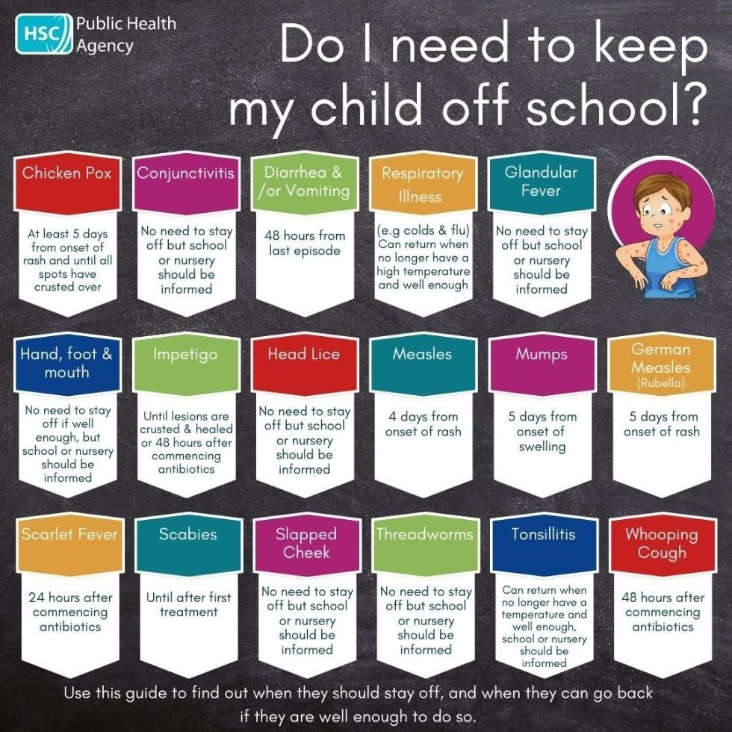



As many children suffer from hay fever please ensure that they carry a packet of tissues.

Transition Programme for Yr 7 pupils (MORE INFO AT THE BACK OF NEWSLETTER)
The Taking the Next Step programme provided by RAPID NI is designed to support P7 pupils as they prepare for their transition to post-primary education, with a focus on building confidence, resilience, communication skills, and positive relationships.
Programme Overview:
- 3 in-school sessions delivered directly within your school setting
- 1 shared session in Derry, delivered in partnership with Children in Crossfire and Verbal Arts (TBC)
- Transport will be provided for the Derry session
- Lunch will also be provided for all participating pupils on the day
The programme offers a valuable opportunity for pupils to engage with peers from other schools, helping to build connections and ease the transition to secondary school.

Shared Education
The children in Yr 1 -3 will take part in a Fun Sports activity on the 14th May in Owenkillew Centre. Children are to wear P.E. Kit and take a snack and drink. They will be back for dinner.
On the 21st May to celebrate Shared ED the children will travel to Pomeroy Forest and enjoy the nursery/fairy trails. Children are to dress for the outdoors and wear suitable outdoor/footwear. They should return at 2pm approx. Take lunch, snack and drink.


Monday 5th May – Bank Holiday

Friday 22nd May – School Closed for Transform Ed Training.

Monday 25th May, Tuesday 26th May, Wednesday 27th May

30th June – School closes 11am.

Post Primary Days


Yr 7 Parents please visit the school website that your child hopes to attend in September 2026 to ensure that transition days are in your diary. There are times when we are not informed of these dates.

Post Primary Schools usually contact the relevant children.


Induction for Yr. 1 Parents

Parents and their children who are starting in Yr. 1 in September 2026 are invited to attend an information session on Wednesday 10th June at 10am – 11am. Children starting Yr. 1 are welcome to visit the classroom on the same day from 10 -11 am.

Scoil Spreagtha

Please find attached a poster for our WhatsApp Community competition.
Spread the word and join by 08/05/26 and you could be in with the chance of winning a £25 One4All gift card!
WhatsApp group link: https://chat.whatsapp.com/Je4QjbmRhFt5VjmyO2iybe

Our Vision: St Peter’s
Growing in Christ and Learning Together in God’s Love

What is the school’s vision and what informs it?

Our ‘Growing in Christ and Learning Together’ vision statement was developed as part of a whole community engagement process in 2024/25. It reflects our strong, caring ethos where all members of the school community are valued and cherished as part of our school family. Our previous school vision Growing and Learning Together in God’s Love was revisited in the school year 2024/25 as part of the engagement process in developing this new School Development Plan.

The school community was very supportive of the motto and wished to retain it. However, at a staff development session and Board of Governors Meeting April/June 2025 where staff discussed at length the vision we have for all stakeholders, all staff worked together to expand the phrase to include the words Growing in Christ as Christ is central to everything that we do at St Peter’s and we are guided by Christ.

As a result, our vision is: ‘Growing in Christ and Learning Together in God’s Love’
The word growing represented how both pupils and adults (staff, parents and Governors) are always learning, reflecting and improving;
The word learning reflected how members of the school community are encouraged to use their various talents and skills to foster a love for learning, ensuring each child is equipped with the necessary skills and knowledge to succeed personally and academically to their full potential, preparing them for a bright future grounded in Christian values.
Together is a very important word as it is all stakeholders together Growing and Learning in Christ – Teachers, parents, children and the school community. It is a journey for everyone connected with St Peter’s.


Staff then collaborated to produce our mission statement.

Our School Mission Statement

At St. Peter’s Primary School, we celebrate the unique talents of every child, fostering an environment of inclusion, respect, friendship and love. Rooted in the teachings of Jesus Christ, we are committed to nurturing each child's personal and spiritual growth. Through our focus on growth and learning, we empower our pupils to develop into kind, confident individuals who live their faith and strive to make a positive difference in the world.
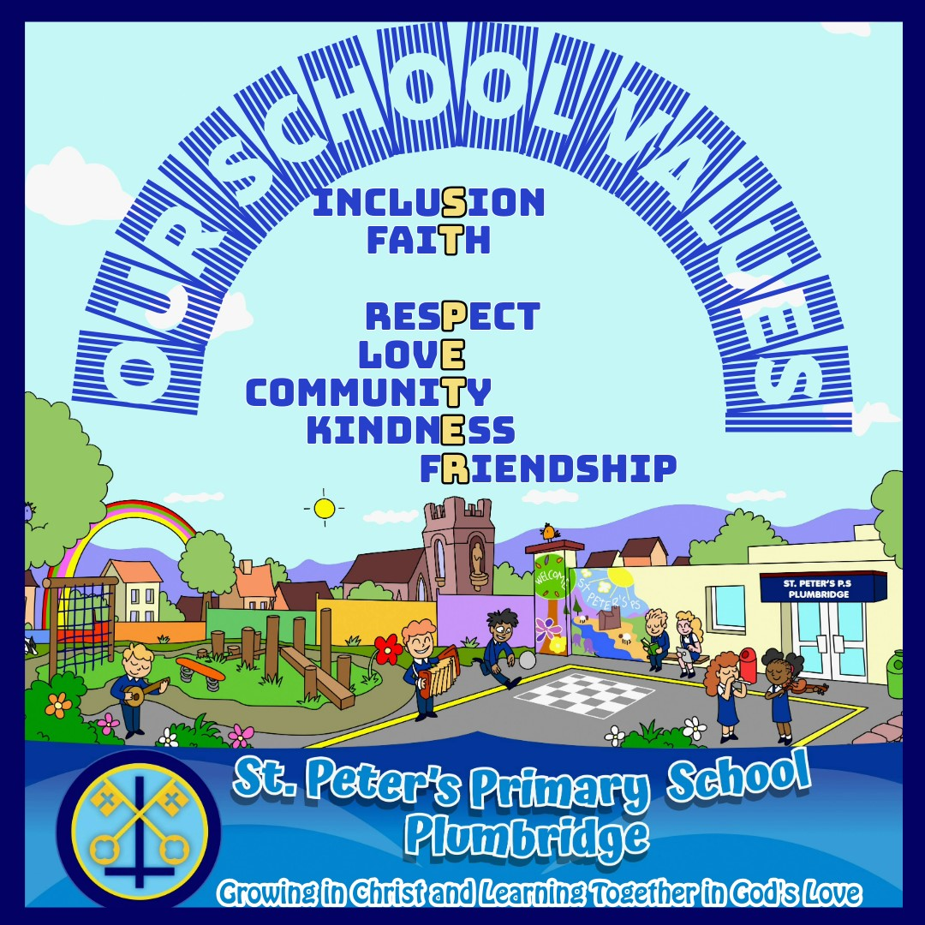

Together at St. Peter’s, our values mean living our faith through kindness, love, respect and inclusion—celebrating diversity, nurturing friendships, growing together in Christ, building friendships with love, resolving difficulties with love, and creating a safe, restorative community where everyone belongs and is empowered to make a positive difference in the world.

The seven core values were decided through consulting with our stakeholders, Parents were asked through a questionnaire to rate the values that they considered to be the most important. Staff and children through workshops on School ethos in April 2025 facilitated by the Derry Diocesan Catechetical Centre and Governors discussed at a Board of Governor Meeting in June 2025. When these top seven values had been collated signage containing the core values were erected in September 2025 in the hall and playground. The values are in no order each is equally important with the word St Peter’s Running through the display of values.

Parents were also invited into the school throughout the year for parent assemblies with each class choosing a core value.
P7- Inclusion;
P4/5- Faith;
P2/3- Respect;
P1/2- Love,
P.6 - Kindness;
Community - Parish Sacraments/ Choir/ Matthew’s Memorial Blitz/ Glenelly G.A.A/ Christmas Shows, Friends of St Peter’s, Choir, School Competitions, Class Assemblies, Author visits, Sponsors and many more events.
P7- Friendship – Leavers Assembly.
In St. Peter’s P.S. Plumbridge, we are committed to making our vision a reality by living out our mission and being committed to our core values each day.

Our School Crest


Our School Crest is circular in shape signifying the never-ending love of Jesus.

The keys of St. Peter, or keys of the kingdom of heaven, symbolize the authority given to St. Peter by Jesus to open and close the kingdom of heaven. In essence, they connect heaven and earth.

The upside-down cross, also known as the Cross of Saint Peter, is a symbol that represents Peter's request to be crucified upside down, as he felt unworthy of dying in the same manner as Jesus. The symbol is often used as a symbol of Peter’s humility.

Our School Crest are represented in the colours of our local Glenelly GAA Team to signify connection to the community.

We pray that like St Peter we will be kind, show love to others, be a good friend, respect everyone, be inclusive leaders in the community and true to our faith.

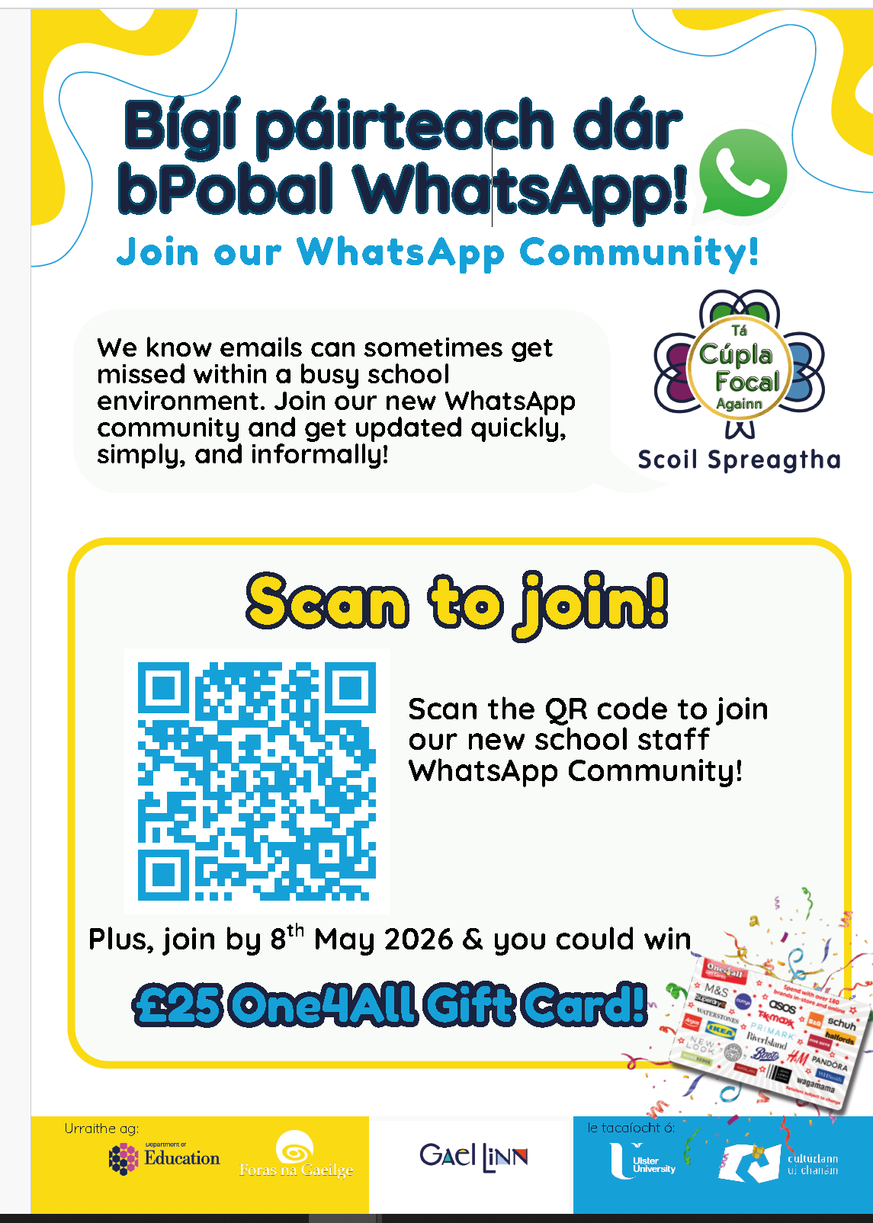

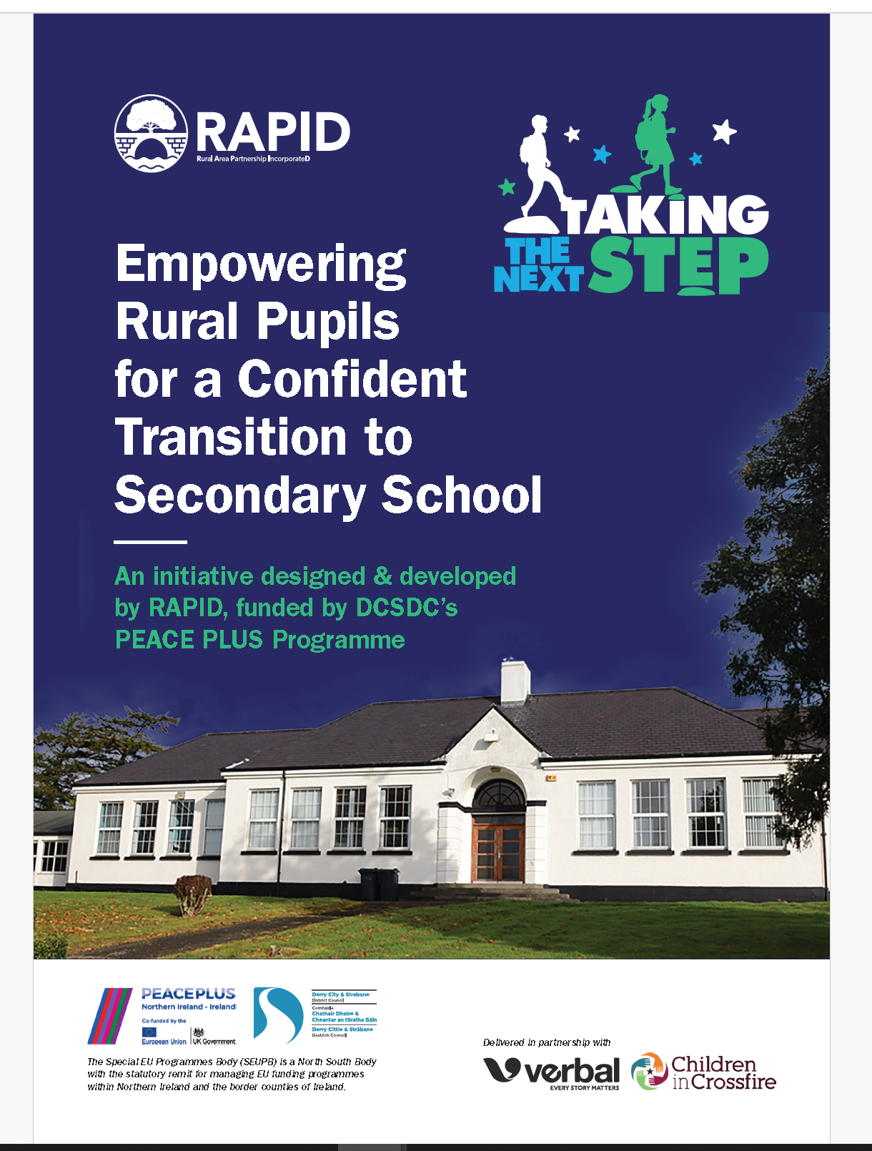

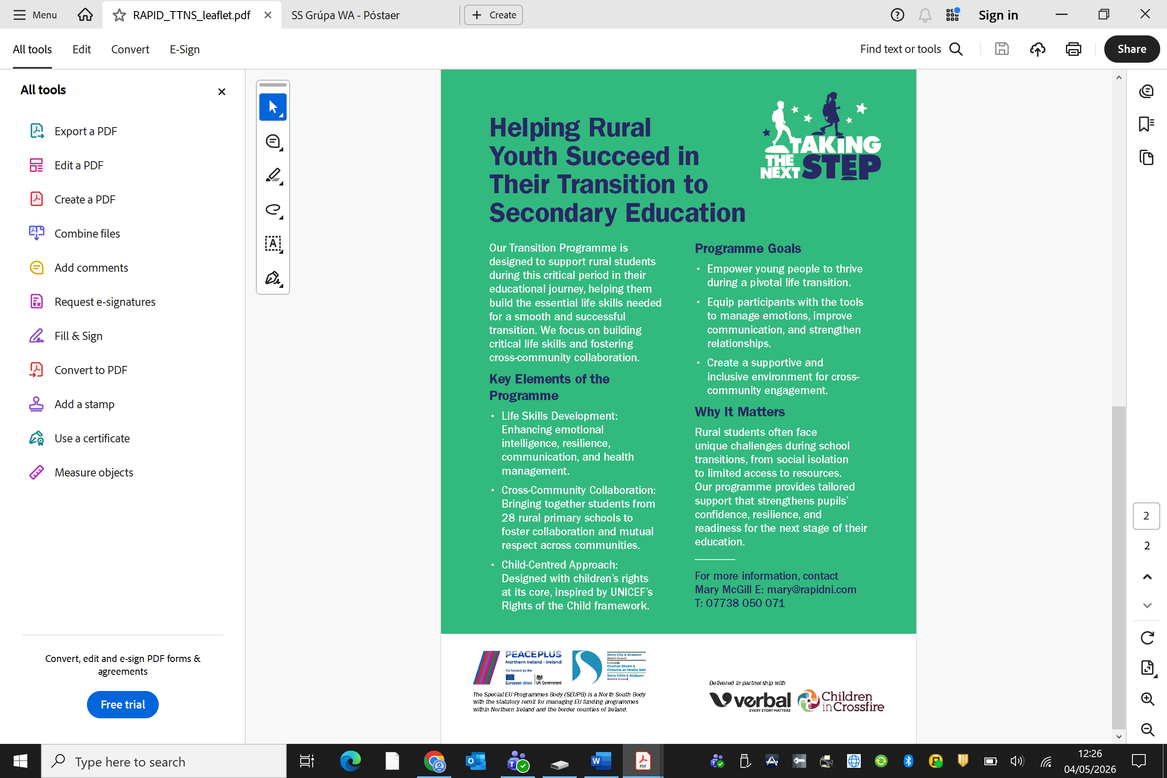

At A Glance Grid

May
Friday 1st May | Flowers for May Altar
Monday 4th May | Holiday
Tuesday 5th May | Yr 1 and 2 Flowers for May Altar
Wednesday 6th May | P6/7 CMnB girl/ Blitz Gortin  P5,6/7 boy Blitz Gortin  Gardening Club Yr 6 class  Cycling Proficiency Yr 7. 2 -3pm
Thursday 7th May | Taking the next steps Programme Yr 7
Tuesday 5th – 23rd May | School Assessments P.3-7.
Monday 11th May | Yr 3 Flowers for May Altar  Yr 4/5 Sports Club - Ryan
Wednesday 13th May | Gardening Club Yr 6  Cycling Proficiency Yr 7. 2 -3pm  Feast of Our Lady Of Fatima -Peace walk around the school.
Thursday 14th May | Shared Education Yr1 -3 – St Peter’s /Gortin P.S./ St Partick’s Gortin – 9.30 – 12.15pm Owenkillew Centre – Sports – Wear P.E. Kit – Take snack and water  Taking the next steps programme Yr 7
Monday 18th May | Registration for Yr 8 at Loreto 4.30pm  Yr 7 Induction Day Sacred Heart College for Yr 8 pupils  Flowers for May Altar Yr 4/5  Yr 4/5 Sports Club - Ryan
Tuesday 19th May | CBS Induction Day for Yr 8.
Thursday 21st May | Yr1/2 & Yr 3 Shared Education St Peter’s at Gortin Schools – Pomeroy Forest – Take Coat, wear outdoor gear and suitable walking shoes. Take snack, lunch and water. 9.30 -2pm.  Gardening Club Yr 6  Cycling Proficiency Yr 7. 2 -3pm  Taking the next Steps Programme – Yr 7
Friday 22nd May | Holiday for children – Transform ED Day
Monday 25th/26th/Tuesday 27th May | Holiday
28th May | Payment for school trip Yr 1 -3 - £15 each and Yr 4 -7 -£20.
June
Wednesday 3rd June | Matthew Memorial Football Blitz  No Gardening Club
Thursday 4th June | Fan the Flames Mass Yr 7. Derry  Take snack, lunch and a drink. Wear uniform. This is the 20th Anniversary of Fan the Flames’.
Wednesday 10th June | Induction Morning for Yr 1 children and their parents beginning in September 2026.10am – 11am.  Cycling Yr 7  Gardening Club Yr 6
Friday 12th June | Provisional Sports Day.
Monday 15th June | School Trip – Arena 7 Letterkenny Yr 1 -7.
Thursday 18th June | Sacred Heart Taster Day P.6 10am – 1pm.
Friday 19th June | School Reports Home  Mrs Mossey’s last day.
Monday 22nd June | Loreto Induction Day Yr 7.- 9.15 – 2pm. Parents transport the children to/from venue.  Mrs Hegarty Returns
Tuesday 23rd June | Leavers Assembly/ Prizegiving 10am Yr 7 parents invited.
Wednesday 24th June | Yr 6 Taster Day at Loreto 9.15 – 2.30pm. Parents transport children to the venue.
Tuesday 30th June | School closes 11am No bus to take children home

There may be more dates to follow so keep an eye on the school calendar.
Also some of these dates may change but hopefully not!

