

🌼 St. Peter’s Primary School
This Photo by Unknown Author is licensed under CC BY-NC
March 2026 Newsletter
A warm welcome to all our families as we begin another busy and exciting month at St. Peter’s.
Format of Newsletter has changed this Month. We welcome any feedback.

📚 World Book Day – Thursday 5th March
Children from Yr 1–7 may dress as a favourite book character. Pupils will share book reviews and enjoy story swaps between classes.
💛 Parents are invited to share a favourite childhood story at home.
Children have already taken home a £1 voucher to spend in a store that supports World Book Day.
We are thrilled to be selected for Children’s Books Ireland’s Every Child a Reader programme. Author Sheena Wilkinson will lead creative workshops throughout the year.
📘 St. Peter’s is the only Northern Irish school chosen this year.

✝️ Confirmation – Saturday 21st March, 3pm
Blessings to our P7 class receiving the Sacrament of Confirmation in the Sacred Heart Church.
All pupils are warmly encouraged to attend and support their classmates.
There will be refreshments in the hall after, the hall ladies have asked if £15 could be sent in from each child by 9th March. Photographer booked.

💙 Lenten Charity – Trócaire & Mary’s Meals
The Student Council will collect small daily donations through the Trócaire Box.
🍞 Toast for Trócaire runs every Friday (20p).
This year’s appeal supports families in rural Rwanda, with additional funds going to Mary’s Meals. Ideas for prayer intentions attached.

🍀 St Patrick’s Day Celebration – Monday 16th March
Children may wear green and enjoy Ceili dancing.
🎉 A lovely celebration of culture and tradition.
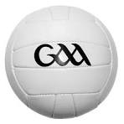
Ryan Mayse – G.A.A. Skills
Ryan will take Yr 4 -7 classes during March. Thank you to Glenelly G.A.A. for funding this programme.

After Schools Basketball Club Yr 6/7
This Photo by Unknown Author is licensed under CC BY-SA
Thank you to all the Teachers who led after schools club. There will be an after schools basketball club on Wednesdays in March for Yr 6/7 from 3 – 4pm.

➕ P.I.N. Numeracy Programme – Begins 3rd March
Yr 3 pupils and parents will complete simple maths games weekly at home for four weeks to strengthen numeracy skills and mathematical language.

This Photo by Unknown Author is licensed under CC BY-NC-ND
Being Well Doing Well Programme
Thank you to everyone who completed the Being Well Doing Well questionnaire last term. Results have been collated and analysed alongside our Link Officer, Gavin Deeney. This is very exciting for our school and we are in the first year of the five-year project. We look forward to using the many wellbeing resources available from EA and can avail from different courses for both staff and parents in the foreseeable future. The wellbeing of our whole school community is important to us!
_________________________________________________________________________________________
🌸 Period Dignity
Free sanitary products are available in the Yr 6/7 girls’ toilets. Pupils may also speak to Miss Falls or any staff member for support.

🧠 RSE Workshop – Wednesday 1st April
Yr 7 will attend a workshop in St Patrick’s, Newtownstewart.
📝 Complete the permission slip which will be sent home soon.

🍀 Scoil Spreagtha – Irish Language Programme
We are delighted to join Scoil Spreagtha, supporting the use of conversational Irish throughout school life. We hope parents will get involved too and encourage your child to speak in Irish and possibly for some learn alongside your child Irish phrases/ Words. It is important to keep the culture alive. Please complete the parental survey – letter attached at end of newsletter.

🌱 Eco-Council
Sustrans will facilitate workshops on Road safety this month.

PANTS Programme
The children responded really well to the Pants Programme and if parents wish to reinforce the message at home, find attached KS1 and KS2 Poster to facilitate discussion.
__________________________________________________________________________________________________
✝️ P4 First Holy Communion Preparation
Yr 4 pupils continue learning through the Friends of Jesus online programme.
Please support your child in practising prayers and Confession format.
🎶 Yr 5–7 pupils are asked to keep Saturday 25th April free to join the choir.

🤝 Shared Education – Yr 1/2/3
We are participating in the ASPIRE Shared Education Project with partner schools in Gortin.
Next session: Yr 1, 2 & s3 Thursday 26th March
🧭 Yr 3 pupils will take part in a local historical walk.
Please send a snack and warm coat.

________________________________________________________________________________________
An Creggan Trip
The Yr 4/5 class will visit An Creggan on the 25th March to take part in our Bog Day Out peatland education programme 9.30am – 2.30pm. The children need to wear waterproofs and suitable footwear. They also need to bring a packed lunch and drink. If you do not consent to photos being taken by An Creggán for promotional or educational purposes, please send a note into Mrs Bradley before 5th March.

🌐 Safer Internet Day
This year's theme, ‘Smart tech, safe choices – Exploring the safe and responsible use of AI,’ focuses on teaching children and young people the skills to use AI technology safely and responsibly, and highlights available support. Pupils joined an assembly on staying safe online.
We encourage parents to:
- Monitor screen time
- Use parental controls
- Check apps and websites regularly
- A letter on AI to parents is attached at the end of this Newsletter and is on our school website under the Parent tab – e - safety guidance.

Feis
Children should be learning their poems at home. If your child has mislaid their copy, please let your child’s teacher know if they need a replacement. Expression will be added to poems when children can recite them.

👩‍🏫 Student Teacher
We warmly welcome Miss Patton, who is completing her placement in Yr 6/7.

🧠 Concussion Guidance
Head injuries are always treated with care. If your child experiences one at school, you will be contacted.
Please monitor your child closely at home.
Further information is available on our website.

🎉 Congratulations
🌟 Erin Mc C (P6) – Our first Word Millionaire Reader this year.
💃 Irish Dancing champions – well done to all competitors!
Paths Pals – Well done to all the children who applied for Paths Pals, all the children were excellent at interview and had great enthusiasm. Pupils have now been trained and commenced their roles in the playground.

📅 Upcoming Holidays
- Tuesday 17th March – St Patrick’s Day
- Fri 3rd April – Mon 13th April – Easter Break
- Thursday 2nd April school will close at 11am. There will be no dinner or buses that day.
Schols have also been told by DENI that there will be two more days for Staff training on Transform ED – Dates are yet to be confirmed.

🌷 Mother’s Day – Sunday 15th March
Wishing all our wonderful mums a very happy and well-deserved day. 💐

🍀 Lá Fhéile Pádraig sona daoibh!
Wishing all our families a happy and safe St Patrick’s Day.
📌 At a Glance – Key Dates for March
📅 Date | 📘 Activity | 👥 Classes
3 Mar | P.I.N. Programme begins | Yr 3 + Parents
4 Mar | GAA Sports with Ryan  After schools Basketball | Yr 4–7  Yr 6 -7
5 Mar | World Book Day – Dress Up  Complete Scoil Spreagtha parental survey online | Yr 1–7  Parents Yr1 -7
6 Mar | Toast for Trócaire – 20p  Return permission slip Yr 7 for RSE Workshop | Yr 1–7  Yr 7
10 Mar | Sustrans Road Safety Workshops  Amma ICT coding Workshop | Yr 1–3  Yr 4/5
13 Mar | Toast for Trócaire | Yr 1- 7
16Mar | Wear Green -Ceili St Patrick’s Day Celebrations | Yr 1–7
17 Mar | School Closed – St Patrick’s Day | —
18 Mar | After School Basketball Club | Yr 6–7
20 Mar | Toast for Trócaire – 20p | Yr 1–7
21 Mar | Confirmation – 3pm | Yr 7 + all invited
25 Mar | An Creggan Bog Peatland Trip Yr 4/5.- Take packed lunch  Wear waterproofs and suitable footwear. Take a drink and lunch  After School Basketball Club. | Yr 4 / 5  Yr 6/7
26 Mar | Shared Education Play Session Yr 1 / 2  Shared Ed Yr 3 – 9.30 -12.30pm. Bring coat. | Yr 1/2/3
27 Mar | Toast for Trócaire | Yr 1–7
31 Mar | Sustrans Road Safety Workshops Yr 4 -7 | Yr 4 -7
1 April | RSE in Newtownstewart | Yr 7
3 April | Easter Holidays – school closes at 11am on Thursday 3rd. | Yr 1- 7
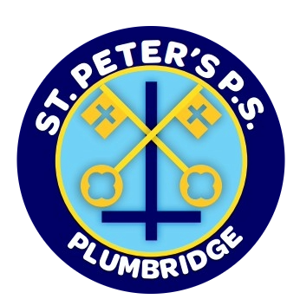
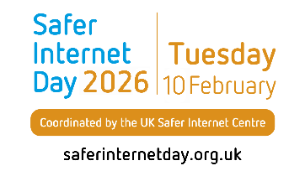

Dear Parents and Guardians,
SUBJECT: EXPLORING THE SAFE AND RESPONSIBLE USE OF AI – SAFER INTERNET DAY 2026
This year, our school will join others nationwide to celebrate Safer Internet Day 2026, the largest global online safety campaign. This year's theme, ‘Smart tech, safe choices – Exploring the safe and responsible use of AI,’ focuses on teaching children and young people the skills to use AI technology safely and responsibly, and highlights available support.
From voice assistants, to chatbots, to algorithms, AI technology is playing an increasingly large role in all our lives. It is important that we find time to discuss these tools and the impact they can have on our own and our families’ online experiences, including:
- the news and content we see
- the way we work, including using AI for homework or studies
- the risk of misuse of AI, for example to create realistic scams or non-consensual nude images
As Safer Internet Day 2026 falls during half term, we encourage you to join us in celebrating by continuing the conversation about AI technology at home. Here are some helpful resources:
- You can complete the UK Safer Internet Centre’s interactive quizzes with your child.
- The UK Safer Internet Centre have created resources for use with children and young people about this year’s theme. These were designed for learning settings but can be adapted to use with your child. You can find these here.
- Read the UK Safer Internet Centre’s tops tips for parents and carers here.
- You can share the UK Safer Internet Centre’s top tips for children and young people with your child.
- You can visit the Safeguarding Board for Northern Ireland’s Online Safety Hub website for lots of advice and support about how to keep your child safer online. It is split into two sections, one for adults and one for young people. It signposts to local support if help is needed.
- The Department of Education also continues to fund the Safer Schools NI App which is available to all school communities and families to help them manage a wide range of safeguarding issues.
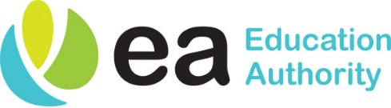
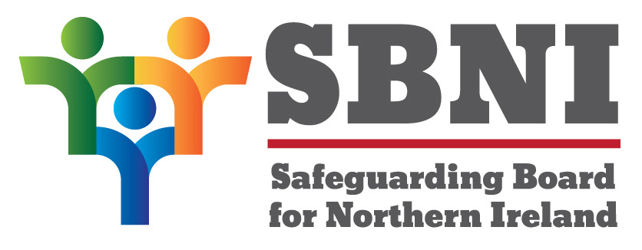


You may also like to use one of these prompts to start a conversation with your child:
- What’s your favourite thing to do online?
- Have you ever used an AI tool? How did it make you feel?
- What do you like about AI technology?
- Do you have any worries about AI technology?
- What advice would you give to your friends about using AI?
- Who would you talk to if you saw something worrying online?
- What more can I do to help you feel safe online?
A key part of protecting children and young people from online harms is through preventative education. By talking about this in school and at home, we can all work towards keeping children safe when they are online. Celebrating Safer Internet Day is a great opportunity for you to re-emphasise the online safety messages we deliver throughout the year.
If you have any concerns or questions about keeping your child safe online, please do get in touch with your child’s class teacher or Miss Falls, our Designated Safeguarding Person.
Kind regards,
M Rouse
ICT Coordinator

When's the right time to talk PANTS?

Every family is different, and when and where you have these conversations may depend on your child's age, or how grown up they are - it's all about whatever feels natural for you and them.
Foundation Stage / Key Stage 1
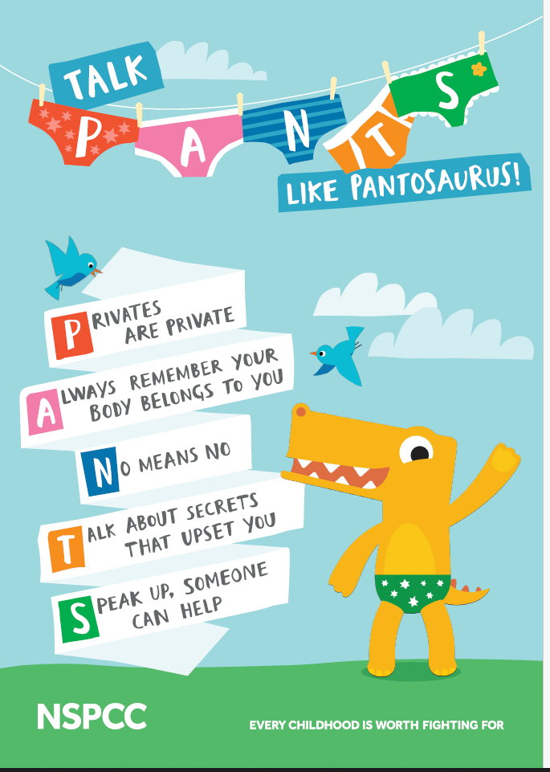

Key Stage 2
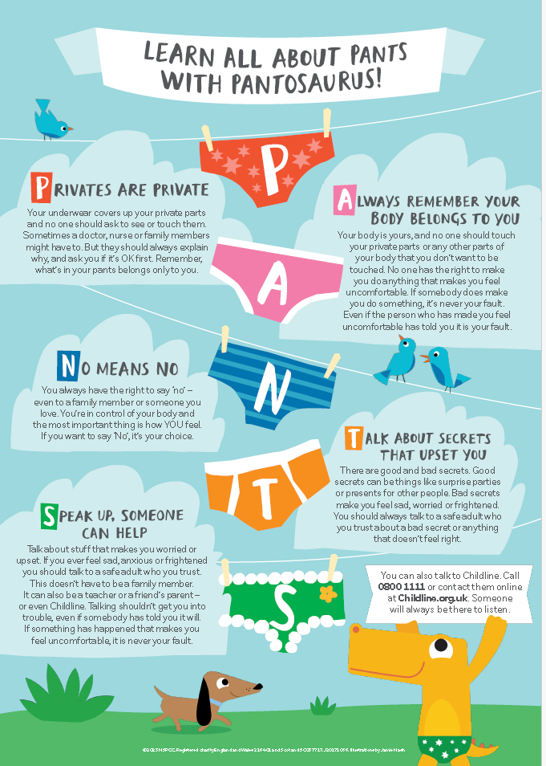

A chairde,
We are delighted to announce that we are taking part in the ‘Scoil Spreagtha’ scheme for 2026.
Scoil Spreagtha is a celebratory, accredited scheme that recognises and encourages the efforts of English-medium schools to promote and increase the use of Irish throughout the school environment.
Scoil Spreagtha aims to inspire and support schools to celebrate, showcase, and expand their efforts to promote the use of An Ghaeilge throughout the school community.
As part of this programme we appreciate your comments so that we can feed back our parental survey at the beginning of this programme. Scoil Spreagtha

Go raibh maith agaibh,
S. Falls
Scoil Spreagtha is delivered by Gael Linn, in partnership with Ulster University and Cultúrlannn Uí Chanáin and is funded by The Department of Education NI and Foras na Gaeilge.

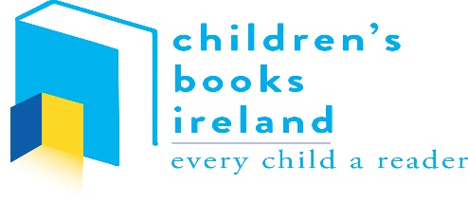

Every Child A Reader programme
St Peter’s Primary school to receive hundreds of new books for their students this year thanks to Children’s Books Ireland

St Peter’s Primary, Plumbridge has been announced as one of the recipients of a book-gifting programme which will bring hundreds of new books and resources to its students in 2026. Designed by national charity and arts organisation Children’s Books Ireland, the ‘Every Child A Reader’ programme is a year-long support provided to select schools which helps to foster a love of reading in their students and wider school community.

As part of this project, each school will have their own dedicated Champion of Reading, an author or illustrator assigned to the school who will host a series of live workshops throughout the year with students. These creative and engaging sessions will help promote a love of reading, writing and illustrating amongst class groups.

Delivered by the team at Children’s Books Ireland, the ‘Every Child a Reader’ programme will bring a diverse collection of excellent contemporary titles to students in 28 primary schools this year, including St Peter’s Primary School – the only Northern School.

Through this initiative Children’s Books Ireland provides schools with a library of 250 books covering all ages, interests, genres and issues which represent the richness and diversity of Irish society. As well as hundreds of brilliant new books, chosen schools will receive supports and resource packs as well as bookmarks, bunting and stickers to celebrate their new library books. Other materials such as curated reading guides, lists and further guidance will also be given to schools and families to encourage a love of reading that endures beyond the school gates. As Miss Falls stated;
“St Peter’s School is absolutely delighted to be selected as an awardee. This recognition is a wonderful affirmation of our students’ enthusiasm and our staff’s dedication to nurturing a true love of reading. The Every Child a Reader and Every Child’s Right to Read programmes embody values that are at the heart of our school community: inclusion, imagination, and opportunity for every child.
We are especially grateful to Books Ireland for providing such a rich range of Irish authors and stories for our pupils. Having access to diverse, engaging Irish literature helps our students see themselves in the books they read, while also opening windows to new experiences and perspectives. For our staff, it is inspiring to witness how these books ignite curiosity, confidence, and joy across the school. This programme is making a lasting difference in our classrooms, and we are proud to be part of it.”

Given the lack of sustainable funding for school libraries from the Irish government, it is unsurprising to see a demand for free book-gifting programmes such as ‘Every Child A Reader’ for primary students and ‘Everyone A Reader’ for secondary students. In 2025, Children’s Books Ireland received over 1,000

applications from primary and secondary schools for the limited number of spaces for the book-gifting programmes commencing in 2026. Of 907 applications received from primary schools only 28 of these could be selected to receive the support provided through the ‘Every Child A Reader’ programme.

According to Education and Advocacy Manager, Dr. Becky Long, the volume of submissions was, “evidence of the tremendous level of need, both in relation to a lack of physical books in schools, and a lack of new, contemporary and inclusive books.”

Children’s Books Ireland believes that every student on the island of Ireland deserves access to books and a chance to fall in love with reading.

This Spring, Children’s Books Ireland’s various book-gifting programmes will be launched in 39 different schools, bringing the power of stories to primary and secondary schools across the island of Ireland. A full list of participating schools in the 2026 book-gifting programmes is available here.

Learn more about the work of Children’s Books Ireland on www.childrensbooksireland.ie

