St. Peter’s Primary School

Newsletter March 2024

Welcome to our March Newsletter. It’s not often that we celebrate St Patick’s Day and Easter in the one month.
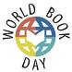
World Book Day

Children from Yr. 1 to Yr. 7 can come to school dressed as a character from a book on Thursday 7th March (optional). It is an opportunity for children to dress up as their favourite character. In class all children will give a short review of their favourite book or character to other children. This year each class will have a story read to them with a science focus.

We also ask parents to share with your child your favourite story book that you read as a child. Children will enjoy the fact that you were once a child and better still if you read the story to them!
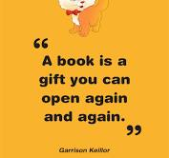
The mobile Library van will visit the school on the 7thMarch, please ensure that your child has their library card with them and any books that they want to return.
In this modern world of technology, it is so important that our children still appreciate the simple pleasure of reading a good book!!!

Children can bring in their books beginning Moday 4th March for a book swap. Please memo these books wont be returned.
The children will also have home their book tokens on Wednesday 5th March.
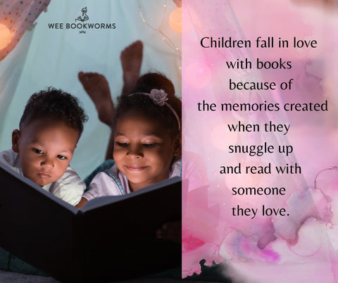
Free Break
Please note that there is a change to free break. Due to planned events free break will now take place on a Thursday. So Free break beginning on Thursday 7th March, 14th March and 21st March.
This Photo by Unknown Author is licensed under CC BY-SA-NC

Confirmation
We wish our P.7 class – Amelia, Annie, Cahir, Caitlin, Casi, Cleiona, Evan, Grace, Grainne and Patrick every grace as they receive their fourth Sacrament on Thursday 14th March at 6.00pm in the Sacred Heart Church. May they be forever under the guidance of the Holy Spirit and stay close to Jesus.
It would be lovely if children in the other classes could make a big effort to attend this sacrament on Thursday evening and show solidarityy to their friends in P.7 on this important day.
The children making their Confirmation can be collected at dinner time -12.30pm on Thursday if Parents wish to make appointments. There will be a photographer present. Refreshments will be available in the hall afterwards.
We are delighted at last to see that parents of children born between 1st April and 1st July -
i.e. the younger P1 pupils, and premature pupils who were due to be born after April 1st
Trócaire

During Lent the Student Council will visit each class with the Trócaire Box. We encourage each child to give a little each day – from an early age it is important to foster compassion and generosity in our children. They are the future. Every Monday each child in the P.4 – 7 class can participate in ‘Toast for Trócaire’ at a cost of 20p. The funds raised will go to helping support families in Malawi and all over the world, not just with immediate life -saving assistance but also with the tools to rebuild their lives in a sustainable way. With kindness and generosity from us, people can start to regain the hope they have lost. So far we have raised £72 in Week One so keep up the excellent work. Together we can make a difference.
Also some of the money raised will go towards ‘Mary’s Meals’ that is a Charity that serves nutritious school meals to children living in some of the world's poorest countries.

St Patrick’s Day Celebration

On Friday 15th March the children will celebrate St Patrick’s Day. There will be a short school assembly at 10 am. All parents are warmly invited to the Assembly. However due to Health and Safety
we need to limit numbers to two adults per family.

Eco - Council

The Eco Council are presently involved with Sustrans and a big thank you to all (children and adults) who were involved in the ‘Walking Bus’. sSustrans have also provided the school with Hi Vis Vests for the children when walking.
Congratulations also to our three prizewinners in the cleaner world competition – Clieona, Gráinne and Róise.
Listening Programme
The Listening RISE Programme will begin for Primary 3 children on Monday 4th March.

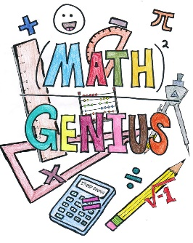
This Photo by Unknown Author is licensed under CC BY
P.I.N. Parental Involvement in Numeracy.

The Parental Involvement in Numeracy Progaramme has started for all Yr. 3 children. This is a programme when parents are asked to play Maths Games with their child twice a week. It helps to promote mathematical language and secure maths concepts. It is also an opportunity to have nurture time with your child.

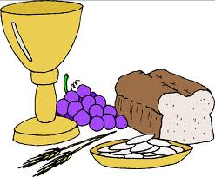
P.4 Communion Programme

The Yr 4 children have been busy preparing for their First Holy Communion by following an online programme called ‘Friends of Jesus’ from the Derry Catechetical Centre. It is important to ensure that your child learns their prayers sent home from school.

We ask all children in Yr. 5 – 7 to keep Saturday 13th April Free so that they join their classmates and participate in the school choir to make this a memorable occasion for the Yr. 4 children on their special day.

RSE Talk
Children who are participating in the RSE Workshop will attend St Patrick’s Newtownstewart on Friday 8th March. Children will be leaving the school at 9am.

Safer Internet Day
The children all attended an assembly on internet safety and guided in the rules for staying safe online.There was lots of discussion about appropriate behaviour online. This must be regularly reinforced at home and parents have a responsibility to monitor screen time, introduce parental locks and carry out site monitoring. Recently there have been a few arguments coming into school about playing games online at home. Parents need to have these discussions with their child and if children cannot play in an appropriate manner sanctions need to be introduced.
Traffic Free Playground
We would like to take the opportunity to remind parents/guardians that no cars are permitted inside the school grounds at any time unless this has been pre-arranged with Miss Falls. Please share this information with grandparents and childminders as refusal often causes offence. Most parents adhere to this rule and we are appealing to the minority to please practise this health and safety measure for the safety of all children. Please ensure that the school gates are kept clear. Please talk to your child about general road safety. Enter and exit the school using the pedestrian gates only. Once your child is collected from school, please keep them beside you at all times. These measures are in the interest of everyone's health and safety. Thank you!

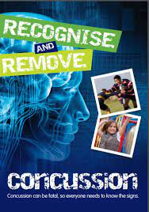
Information to Parents on Concussion

Concussion is a brain injury which is usually caused by hitting the head or a fall. It can happen at any time, anywhere: for example, during P.E., in the school playground, or at home.
Concussion must always be taken seriously, and it is vitally important that any child/young person suspected of having concussion should immediately be stopped from continuing whatever activity they are doing and be assessed by a medical professional for diagnosis and guidance.
If your child suffers a concussion in school or outside school, it is vitally important that you keep all people/organisations with responsibility for caring for your child informed so that they are aware of the potential dangers and any restrictions that may apply to the activities your child is permitted to do.
The ‘Recognise and Remove’ leaflet produced by the Department of Education and the Department of Culture, Arts and Leisure is available on the school website and provides guidance on the signs to look out for.
Please do visit and read.
In school if a child falls and obtains head injury parents are phoned and informed and you are asked to make a judgement on their child’s injury. It is important that parents are familiar with the signs and when a child is collected at school it is important that they are monitored at home (not playing alone or having a nap).

Please do read the school website and calendar for quick updates.

Congratulations
This Photo by Unknown Author is licensed under CC BY-SA-NC
Well done to
- Aóibhin (P.5) and Aimee (P.6) and Cahir (P.7)who won medals at the Cross country Event in Strabane.
- Aóibhin (P.5) who has become A Word Millionaire Reader.
- To a large group of children who have won medals and trophies at various Irish Dancing Feis – it is superb to see that the future of Irish dancing is looking bright in Plumbridge. Keep it up.
- Congratulations again to our prize winners as seen on the school website for gaining medals at the recent gymnastics competition.

Past Pupil Congratulations

Well done to our past pupil Thomas Coyle and CBS on recently winning the 2024 MacRory Cup.
Also Congratulations to Harley Patton on his selection for 2024 Tyrone Minor Panel.
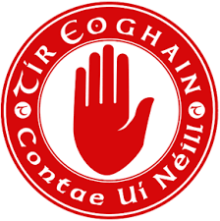

Holidays

Monday 17th March – St. Patrick’s Day break

Friday 29th March – Fri 5th April (inclusive) – Easter break
The school will close at 11am on Thursday 28th March.
Please note that there will be no school buses on Thursday 28th March, children who travel on a bus will be marked present.
Mother’s Day
Wishing all Mums a happy day on Sunday 10th March. Hope you all get spoiled!!!

Wishing Everyone a very Happy St. Patrick’s Day!
Lá Fhéile Pádraig sona duit!

Have a holy, happy and safe Easter from everyone at St Peter’s.

