St Peter’s Primary School
Newsletter
November 2023
Welcome back to the second half of Term 1, the days are flying and Christmas is only around the corner.
Month of the Holy Souls/Saints
During November the Christian community pray all those who have died. May they Rest in Peace. We will remember Matthew who is always in our prayers. Every classroom will have an area for each child to display the name of their loved ones.

Maths Week
Well done to everyone who took part in Maths Challenge. The children enjoyed the idea that parents had homework!
Winners of the Maths week competitions are;
Foundation Stage;
Yr. 1 – Shea, Daithi, Sophia

Yr. 2 – Eva, Rose, Grace
Key Stage 1;
Yr. 3 – Evie, Sarah, Danny
Yr. 4 -Erin, Caelin, Logan
Key Stage 2;
Yr.5 – Catlin, Alice, Eireann Winners of the Estimation Challenge
Yr. 6- James, Sarah, Roíse P. 1 - P.3 - Arianna
Yr.7 – Gráinne, Amelia, Cahir P.4 - P.7 - Michael

Teacher/Pupil Challenge
The children enjoyed the various challenges and lots of fun was had by all. Thank you to the pupils and staff for being such good sports. It is with great delight I can announce that the Teachers WON. All the extra training paid off! Congratulations Teachers!!!! Maybe next year Kids………………….

Eco Council
Yvonne Lecky from Strabane District Council invited the Eco Council to the Recycling Depot. In Plumbridge so that the children got to see the various products that can be recycled.
The children also had a visit from Sustrans who emphasized the importance of renewable energy and even left us our own mascot teddy to name.
Sustrans -Workshops
There will be a workshop on Friday 10th Nov. for P.1 children ‘Ditch the Stabilizers’ (Details sent home)
There will be a workshop for P.7 pupils on Friday 10th Nov. ‘Pedal Safety – (Details sent home).
Halloween
Well done, to everyone who looked spooktacular at Halloween.
Butterlope Farm
The P.5 – 7 children will now visit the farm on Thursday November 30th. There
is a change of date due to Industrial Action. Please bring a snack, a packed
lunch and a drink. Wear Waterproofs and wellies. Bring a change of shoes for
the classroom!
This Photo by Unknown Author is licensed under CC BY-NC
Mini Professors
On Monday 13th November the P.2/3 children will visit the Plum Hall in the morning to take part in a science programme designed specifically for young children. The P.1 children had great fun when they took part in their workshop.
Flu Vaccine
The Nurse will visit the school on Monday 13th November to give the children the Flu vaccine.
Anti – Bullying Week
The theme for Anti - Bullying Week 2022, which is taking place from Monday 13th – 17th November is Make a noise about Bullying.
Too often, we are silent when we see bullying take place, silent about the hurt bullying causes, and silent when we hear bullying dismissed as ‘just banter’.
It doesn't have to be this way.
Of course, we won’t like everyone and we don’t always agree, but we can choose respect and unity.
This Anti-Bullying Week let’s come together to have discussions about what bullying means to us, how banter can turn into something more hurtful, and what we can do to stop bullying. Together, we can make a difference and take a stand against bullying.
From the playground to Parliament, and from our phones to our homes, let’s make a noise about bullying.
During this week there will be a school assembly on this theme and the teachers will follow up with anti bullying lessons. There will also be homework in this area. As parents it is important that you listen to your child and you may find the Tips for Parents useful at the end of this newsletter. Also make yourself familiar with St Peter’s Anti – Bullying Policy on the school website. Remember the first step is to discuss with your child’s class teacher, do not let problems build. The children will also complete a questionnaire on bullying. At school we inform them about bullying and how to respond to situations but it is essentail that parents discuss this positively at home and reinforce the work at school.
This week we are delighted that the children in Yr. 4 -7 will obtain a workshop from Hip Psycology Ireland on the theme of Bullying. This will be a live online workshop with other schools and will allow the children time to reflect and discuss on various scenarios.

Odd Socks Day
On Monday 13th November we begin Anti Bullying Week by asking the children to wear odd socks to school.
Odd Socks Day is the perfect opportunity to encourage people to express themselves and celebrate their individuality and what makes us all unique! All you need to do to take part is simple wear odd socks! What could be easier?
Union Action Short of Strike

The Education Authority (EA) has warned of expected disruption to some school services as a result of industrial action notified by UNISON. This action will consist of action short of strike from 16th October 2023 to 20th November 2023 as well as a full day of strike action on 16th November 2023. The EA is working with schools, youth services and partners to minimise any disruption to children and young people caused by the industrial action. However, despite this, there will be disruption to some services; at this stage the EA anticipate that the impact is likely to be most significant across some classroom assistant, catering and cleaning services. We encourage parents/carers to check the EA website for regular updates and details of any planned disruption on www.eani.org.uk/industrialactionupdates
- N.B. In the event of staff absence this ‘Action Short of Strike’ may have a direct impact on supervision and we ask parents/guardians to have alternative arrangements in place should this situation arise.
Party Invites
As a school, we ask that Birthday Party Invites are not distributed in school or at hometime at the school gates. This is purely because when children in the class do not get an invite it is upsetting for them and becomes a memory that is hard to erase. We do like children to celebrate their birthday but do consider alternative methods e.g digital and more importantly the feelings of other children in the class. No one, no matter what age likes to feel left out.
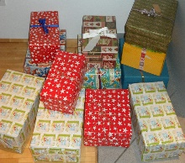
Shoebox appeal
By filling a shoebox with basic items, you can bring joy to those in need this Christmas. All children have already received a leaflet which should be glued to the top of the box – a leaflet can also be printed from the school website. All Boxes will be collected on Tuesday 28th November. Please send boxes into school the week beginning Monday 20th November as we have limited storage.
Friends’ of St Peter’s
Friends’ of St Peter’s is a small team of parents who work so hard to raise funds each year, to help purchase essential school resources for the benefit of our pupils. This year we are seeking new members to join our team and particularly encourage any mums or dads who are interested to please join up, as we need extra hands to help share the workload!!! To give you some idea of the level of commitment involved, the committee holds meetings once or twice a term and hold two/three main fund-raising events each year. If you are interested in joining ring the school office and leave your name.
- Lotto Ball – Congratulations to the Sayers Family on winning the Family Portrait. Thank you to all who purchased a ball. The money raised will go towards buying a computer screen for the Computer room.
- Scarecrow name
The name of the baby girl scarecrow was ‘Wednesday’. Thank you to everyone who took part.
- Cash for Clobber
The collection point is Glenelly GFC clubrooms and the dates and times for dropping off are as follows: Monday 6th, 13thand 20th November from 6 – 7pm.
Please check Friends of St Peter’s via Facebook page.
Christmas Wreath Making
On Tuesday the 12th December there will be Christmas Wreath making in Glenelly House. Check Friends’of St Peter’s Facebook page.
Big Breakfast

Friends of St Peter’s are organising an event in Plumbridge Hall on Sunday 10th December after 10 am Mass. Details on school website and Friends of St Peters Facebook page.

Free school meals/uniform
Please have a look at the EA website https://www.eani.org.uk/financial-help/free-school-meals-uniform-grants to register your child for free school meals and uniform grant. If you are eligible for free meals and do not wish to avail of them, please register as the numbers of children eligible helps to raise our school budget. There is still time to apply.
Spring Bulbs for Schools Investigation
The Primary 4 and 5 class will start their Edina Trust Bulb Project 2023. The children will plant daffodils and a variety of mystery bulbs which they will monitor over the coming months. Pupils will measure/record rainfall and temperatures as part of a research project funded by the National Museum Wales. Results and findings will be collated with participating schools in Northern Ireland, England, Wales and Scotland. This is a great project for children to become young scientists and learn about the importance of fair testing alongside enjoying the beauty of nature and working towards maintenance of the Green Eco Schools Flag.

Paths Quote for November
As we continue with our Paths programme in all classes – a programme that deals with important issues such as Feelings, Behaviours, Solving problems, Making Friends and Self – Esteem. The Paths quote for November is
‘Wouldn’t it be a wonderful world if everyone followed the Golden Rules
Let’s show the world how to do it by treating others the way we want to be treated.’

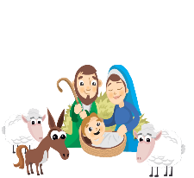
This Photo by Unknown Author is licensed under CC BY-NC

Christmas Carol Service
This year the school will have a Carol Service on Wednesday 13th December at 6.30pm in the Sacred Heart Church in Plumbridge. Everyone Welcome.
Christmas Tickets
Every year there is a book of tickets sent home with each family. This is our main source for school funds, and we would appreciate if all families could buy a book. Indeed, if you wish to sell more, please ask for more books. Thank you to all our sponsors who have been very generous, it is greatly appreciated.
Weather warnings

It is the time of year again when there can be severe weather warnings. Therefore, we are asking you on these mornings to ensure that there is a member of staff present in the building before dropping off your child as staff can be delayed travelling to school.
On snowy/frosty mornings please check the school website as the school may be closed. If you do not have internet access, please ensure to link up with other parents who will call you on these mornings. (Also be aware that if the electricity is off, parents cannot be contacted, so please make an informed decision on such mornings.) Staff will make every effort to come to school but if staff can’t make it to school, children will have to be collected. (Have a Plan B ready!).
Enterprise Afternoon
The Student Council will send out a letter giving more details but meanwhile boys and girls in P.5 -7 can be thinking about their ideas! This is a chance to be creative and sell products for a minimal price… (bracelets, pictures, decorated pebbles/stones, buns, bows, etc).

Christmas Dinner

Christmas dinner will be served on Friday the 8th December at the normal cost of £2.60. To gauge numbers, we request that you complete the slip attached and forward the appropriate fee for the meal as soon as possible. (Those on free school dinners do not have to request a dinner).
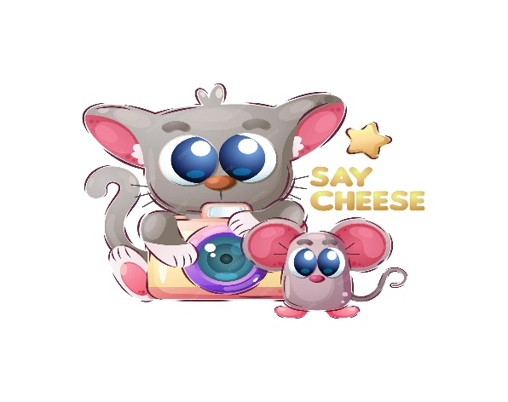
Thought for the Month
Life is like a camera …..
Focus on what’s important, capture the good times,
develop from the negatives and if things don’t work out
take another shot!!!

Thank you to everyone who contributed so generously to Friends’ of St Peter’s Fundraising – Money raised will buy a big screen for the upstairs classroom. Thank you to the Friends’ of St Peter’s who organised the events superbly.
Memo Snapshot

Monday 6th November | Cash for Clobber GFC Clubroom 6-7pm
Friday 13th November | Sustrans – P.1 Ditch the stabilizers  P.7. Pedal Safety
Monday 13th November | Flu Vaccine  Mini Professors P.2/3  Odd Socks Day  Cash for Clobber 6-7pm
Tuesday 14th November | Anti Bullying Assembly Anti Bullying Ambassadors
Wednesday 15th November | Anti Bullying Megathon P4-7.
Thursday 16th November | Strike Action – have plans in place for disruption.
Monday 20th November | Cash for Clobber 6-7pm
Tuesday 28th November | Shoebox Appeal Collection
Thursday 30th November | Butterlope Farm P5-7
Friday 1st December | Discover Drumragh Integrated Day P.7. 9.45 – 12.30pm.
Friday 8th December | School Christmas Dinner
Sunday 10th December | Big Breakfast
Tuesday December 12th December | Christmas Wreath Making
Wednesday 13th December | Christmas Carol Service 6.30pm
Thursday 21st December | Christmas Holidays 1/2-day closure

Return – Christmas Dinner slip by 10th November.

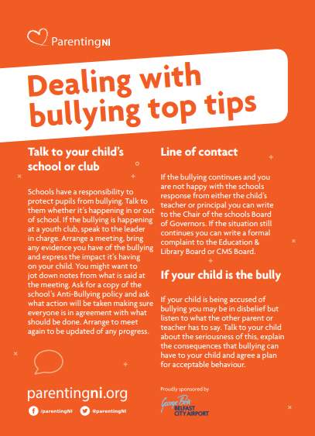
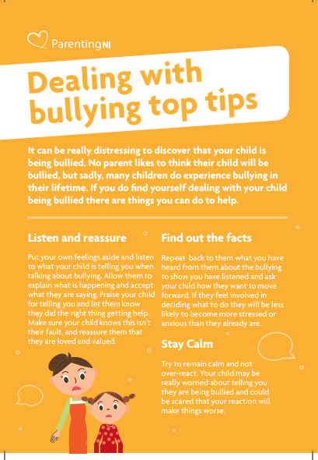

Christmas Meal 2023

My child/children ____________________________________________________
wish to avail of a Christmas meal on Friday 8th December at the cost of £2.60 each.

Signed: ___________________________________

Return by 10th November.

