St. Peter’s Primary School

Newsletter March 2023

Welcome to our March Newsletter. It’s nice to know that the sun won’t set before 6 pm again until October 29th!
World Book Day
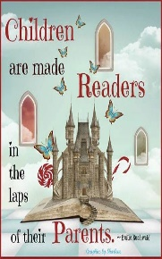

Children from Yr. 1 to Yr. 7 can come to school dressed as a character from a book on Thursday 2nd March (optional). It is a great opportunity for children to dress up as their favourite character. In class all children (regardless of if they are dressed in costume) will give a short review of their favourite book or character to other children. Each class will visit a different classroom and enjoy listening to a story and do fun follow up activities. There will also be some spot prizes on the day.
We also ask parents to share with your child your favourite story book that you read as a child.
The mobile Library van will visit the school tomorrow so please ensure that your child has their library card with them and any books that they want to return.
In this modern world of technology, it is so important that our children still appreciate the simple pleasure of reading a good book!!!

Confirmation
We wish our P.7 class - Cara, Daire, Dara and Jamie every grace as they receive their fourth Sacrament on Wednesday 15th March at 6.30pm in the Sacred Heart Church. May they be forever under the guidance of the Holy Spirit and stay close to Jesus.
The children making their Confirmation can be collected at dinner time -12.30pm on Wednesday if Parents wish to make appointments. There will be a photographer present. Tea will be available in the hall afterwards. It would be appreciated if each child making their confirmation could bring in £15 for the hall committee on or before Monday 6th March.
We are delighted at last to see that parents of children born between 1st April and 1st July -
i.e. the younger P1 pupils, and premature pupils who were due to be born after April 1st
Trócaire

During Lent the Student Council will visit each class with the Trócaire Box. We encourage each child to give a little each day – from an early age it is important to foster compassion and generosity in our children. They are the future. On Fridays each child in the P.3 – 7 class can participate in ‘Toast for Trócaire’ at a cost of 20p. The funds raised will go to helping support families in Somalia and all over the world, not just with immediate life -saving assiastance but also with the tools to rebuild their lives in a sustainable way. With kindness and generosity from us, people can start to regain the hope they have lost.

St Patrick’s Day Celebration
On Thursday 16th March the children will celebrate St Patrick’s Day. There will be a school assembly at 10 am. All parents are warmly invited to the Assembly. However due to the size of our hall we do have to limit numbers to two adults per family.
A Bridge to France
On the children in Yr 5 -7 as part of their STEM project on ‘A Bridge to France’ will visit W5 in Belfast. The children need to be in school for 9.00 am that morning wearing their school uniform and taking a snack, bottle of water and a healthy lunch. Children on Free school dinners can request a lunch from the kitchen by ringing the school office on or before Monday 6th March.

School Council

The School Council wishes to thank everyone who contributed to their
‘Fireside Quiz’ – it certaintly made you think! The answers are on the
website!!! Well done to – 1st Prize – Oísin P.1. ;2nd Prize – Damien Quinn,
3rd Prize -Linda Sayers The children made a grand total of £85. They had a lot lot of fun looking at the entries and working out the profit, early
entrepreneurial skills! The money will go towards buying some small play
equipment – e.g.skipping ropes/tennis balls.

Eco - Council

The Eco Council have been very busy as the closing date for renewing the Green Flag is fast approaching. Action plans are being reviewed, bird and bat boxes erected, compost bins in every classroom, new plants to encourage pollination planted around the school. The school has also signed a pledge to reduce plastic and all children have received a free water bootle to encourage refill.

After School Clubs

The Eco Warriors and Choir Club will continue to the end of March.

Reminder P.E. Day has changed this term

The Yr. 3 -7 P.E Day has changed from Wednesday to a Tuesday. So please ensure your child wears their P.E. Kit on a Tuesday and Friday only.
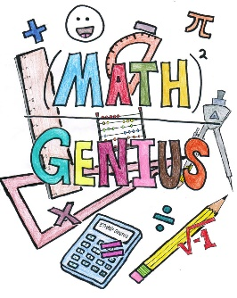
This Photo by Unknown Author is licensed under CC BY
P.I.N. Parental Involvement in Numeracy.

The Parental Involvement in Numeracy Progaramme will begin this week for all Yr. 3 children. This is a programme when parents are asked to play Maths Games with their child twice a week. It helps to promote mathematical language and secure maths concepts. It is also an opportunity to have nurture time with your child.
Dental Hygienist

Research in the Western Board Area has sadly shown that many children from an early age are not encouraged to look after their teeth. All children in Yr. 1 and 2 will shortly receive a toothbrush and toothpaste and it is important that children brush their teeth each morning and night. It is important to promote life time skills and good habits from an early age.

Yr. 7 Transition to Post Primary School

The children in Yr 7 are enjoying their workshops on preparation for Post Primary Schools. They are learning how to read timetables, role playing various situations that could arise and taking part in Quizzes.

P.4 Communion Programme

The Yr 4 children have been busy preparing for their communion by following an online programme called ‘Friends of Jesus’ from the Derry Catechetical Centre. It is important to ensure that your child learns their prayers sent home from school.

Safer Internet Day
The children all attended an assembly on internet safety and guided in the rules for staying safe online.There was lots of discussion about appropriate behaviour online. This must be regularly reinforced at home and parents have a responsibility to monitor screen time, introduce parental locks and carry out site monitoring.

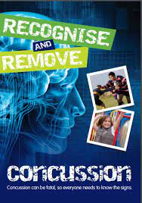
Information to Parents on Concussion

Concussion is a brain injury which is usually caused by hitting the head or a fall. It can happen at any time, anywhere: for example, during P.E., in the school playground, or at home.
Concussion must always be taken seriously, and it is vitally important that any child/young person suspected of having concussion should immediately be stopped from continuing whatever activity they are doing and be assessed by a medical professional for diagnosis and guidance.
If your child suffers a concussion in school or outside school, it is vitally important that you keep all people/organisations with responsibility for caring for your child informed so that they are aware of the potential dangers and any restrictions that may apply to the activities your child is permitted to do.
The ‘Recognise and Remove’ leaflet produced by the Department of Education and the Department of Culture, Arts and Leisure is available on the website and provides guidance on the signs to look out for. Please do visit and read.
In school if a child falls and obtains head injury parents are phoned and informed and you are asked to make a judgement on their child’s injury. It is important that parents are familiar with the signs and when a child is collected at school it is important that they are monitored at home (not playing alone or having a nap).

Please do read the school website and calendar for quick updates.

Congratulations
This Photo by Unknown Author is licensed under CC BY-SA-NC
Well done to
- Aoibhin P.4 and Aimee P.6 who won medals at the Cross country Event in Strabane.
- Grainne P.6 and Róise P.5 who have become muti word Millionaire Readers.
- Chloe and Alice who won medals and trophies at the Irish Dancing Feis.

Holidays

Friday 17th March – St. Patrick’s Day break

Thursday 6th– Fri 14th April (inclusive) – Easter break

Mother’s Day
Wishing all Mums a happy day on Sunday 19th March. Hope you all get spoiled!!!

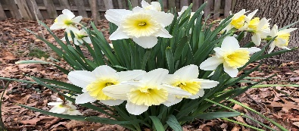
Enjoy the little things in life.

For one day you may look back
and realise they were the big things!!

Wishing Everyone a very Happy St. Patrick’s Day!

