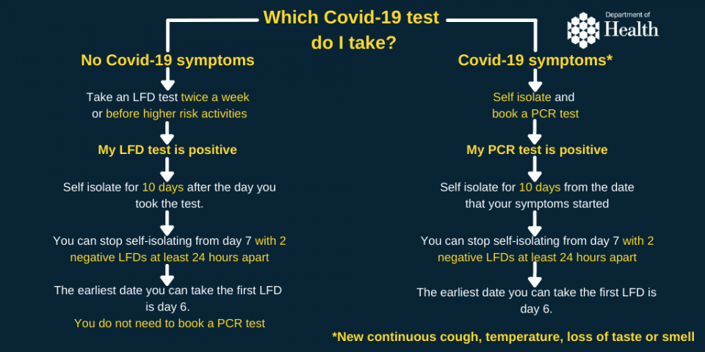

If you have a positive COVID-19 test, the earliest you can end your period of self-isolation is on day seven - providing your lateral flow tests on day six and seven are both negative and you do not have a high temperature.
Your day six and day seven lateral flow tests should be at least 24 hours apart.
If either is positive, you should continue to isolate until you get two negative lateral flow tests taken 24 hours apart, or after you have completed 10 full days of isolation – whichever is earlier.

