CHRISTMAS RAFFLE PRIZE WINNERS 2021
 |  | Winners
1ST PRIZE | £100 CASH | Dermott McConnell
2ND PRIZE | £50 CASH | Caelin McGillion
3RD PRIZE | Christmas Wreath | Patrick McGlinchey
4TH PRIZE | £25 CASH | Peter Harley
5TH PRIZE | Playstations Pass | Clodagh McCullagh
6TH PRIZE | Playstations Pass | Cleiona Furey
7TH PRIZE | Playstations Pass | Eireann McConnell
8th PRIZE | Playstations Pass | Sarah Gormley
9TH PRIZE | Playstations Pass | Patrick Kearney
10TH PRIZE | Playstations Pass | Chloe Neely
11TH PRIZE | Playstations Pass | Orla McGillion

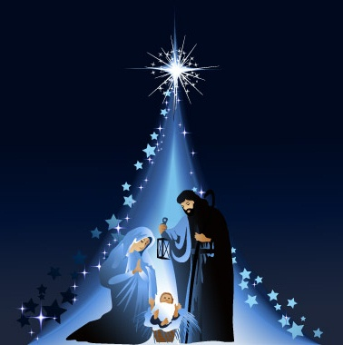
Thank you for your support throughout the year.
Happy Christmas.

