CHRISTMAS RAFFLE PRIZE WINNERS 2020
 |  | Winners
1ST PRIZE | £100 CASH | Gerard Mc Cullagh  C/o Erin P.1.
2ND PRIZE | £50 CASH | Roisin O’Neill
3RD PRIZE | £40 CASH  Donated by Express Cooling | Joanne Conolly  c/o Chloe P.2.
4TH PRIZE | £25 CASH | Blathnaid Kearney
5TH PRIZE | BOX OF CHOCOLATES | Bronagh Kearney
6TH PRIZE | BOX OF BISCUITS | Fearghal Kearney
7TH PRIZE | BOTTLE OF WINE  Donated by Casi Dooher | Leanne Mc Bride
8th PRIZE | SHORTBREAD MUSICAL HOUSE  Donated by Dani Dooher | Emma Bradley  C/O Daire P.5.
9TH PRIZE | Box of Sweets  Donated by Dakota McTigue | Rachel Holland  C/O Meabh P.1.
10TH PRIZE | Box of Sweets | Colette Mc Cullagh
11TH PRIZE | Box of Sweets | Harper Rose Hogan  C/O Aiden P.6.
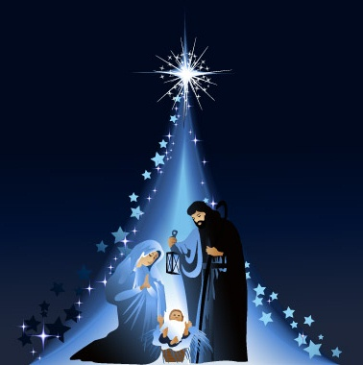
Thank you for your support throughout the year. Happy Christmas.

