3rd July 2020

The following information has been adapted from information provided by the Department of Education (DE).
Please note engagement with this work is optional.

ONLINE SUPPORT FOR CHILDREN ENTERING YEAR 7

Dear Parent,
The Department of Education (DE) has proposed a scheme whereby all current year 6 children and their parents may access online learning programmes in English and maths.
Children will require access to a tablet, laptop or smart phone to access the programmes. One of the resources suggested by DE is a commercial programme called MathematicsMastery, which contains numeracy and literacy (despite its name suggesting only maths).
As with the use of any online programme or application it will be important that parents consider both appropriate levels of screen time and their child’s online safety. Parents may find the EA online safety guidance material useful:

https://ineqe.com/safeguarding-hub/
https://www.saferinternet.org.uk/advice-centre/parents-and-carers

In addition the ‘Supporting Learning’ material available on the Education Authority (EA) website and specifically EA designed material, link directly with Northern Ireland Curriculum, provides reinforcement and a reminder of the key literacy and numeracy concepts across Key Stage 2.

MATHEMATICS MASTERY:
Mathematics Mastery provides a structured programme for literacy and numeracy and step by step guides for parents.
Parental access to the programme is straight forward, there is no need to register just access the ‘Free Covid-19 Resources’ at the top of the Mathematics Mastery homepage:
https://www.mathematicsmastery.org/
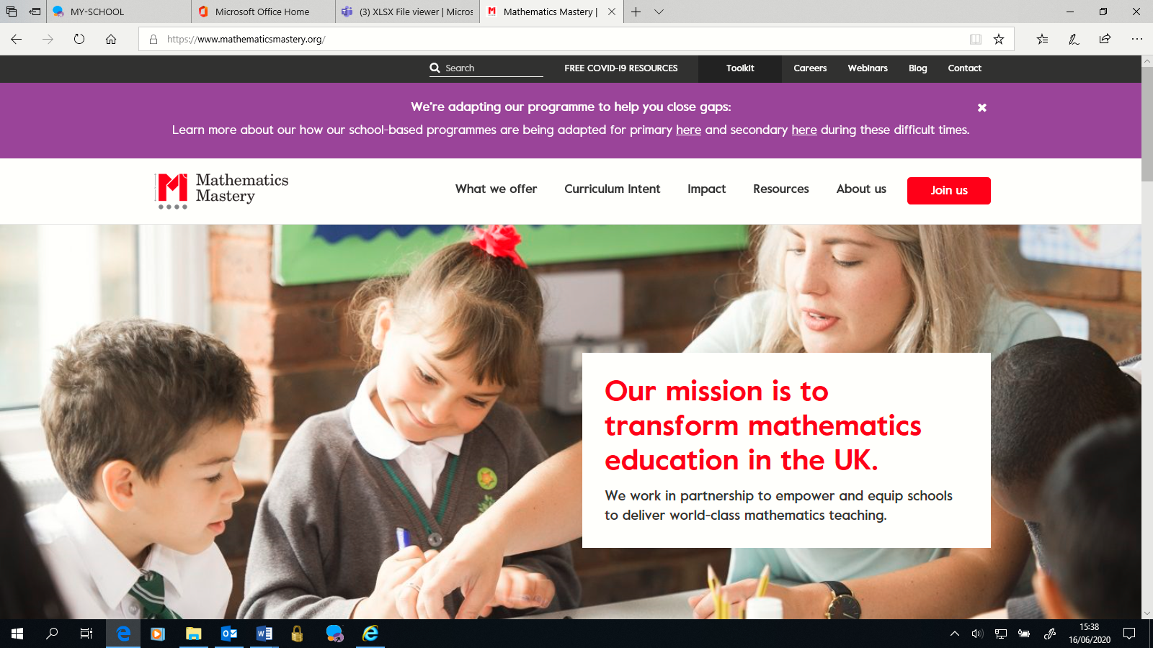
There are two maths packs for each year group, one has the guidance pages and the other the pupil facing resources. Parents need to access both packs as the pupils’ packs do not make sense without the guidance. To reduce printing, the guidance packs can be accessed digitally as they contain embedded video links.
There are also two literacy packs with the guidance included.
Year 5 [approximately equivalent to year 6 in NI] printable packs
- Maths Year 5 Weeks 1-4 Guidance pack (easy for parents/guardians to guide learning)
- Maths Year 5 Weeks 1-4 Pupil pack
- Maths Year 5 Weeks 5-9 Guidance pack (easy for parents/guardians to guide learning)
- Maths Year 5 Week 5-9 Pupil pack
- English Year 5 Workbook (week 1-4) (guidance included)
- English Year 5 Workbook (week 5-9) (guidance included)

Please note: this programme is designed for the English Curriculum and therefore Year 5 is Primary 6 in our NI Curriculum.

NB: St Peter’s PS: Abacus Maths will also continue to be available for use during the holidays and you have been provided with a link to AQE papers.
However at St Peter’s we feel that all children should enjoy the holidays in light of no transfer Tests for the local schools. Health and Well Being of your child is very important.

